

IMAGING DICOM GATEWAY IMPORTER
USER MANUAL

July 2010

Department of Veterans Affairs
Office of Enterprise Development
Health Provider Systems

Preface
The purpose of this document is to help users understand the operation of the Importer application that resides on the DICOM Image Gateway and which is used to transfer DICOM objects from studies performed outside of the VA into VistA Imaging. The Importer can also be used to correct and import locally acquired DICOM objects that were rejected by VistA due to patient and/or study identification information mismatch.

Revision Table

Rev | Date | Notes | Notes
.1 | 05-15-2009 | Document Creation. | Peter Kuzmak and D. Smith
.2 | 01-26-2010 | Substantial update | Peter Kuzmak
.3 | 03-26-2010 | Added Appendix B and Appendix C | Peter Kuzmak
.4 | 03-29-2010 | Added Appendix D | Peter Kuzmak
.5 | 04-08-2010 | Added section on deleting studies | Peter Kuzmak
.6 | 04-13-2010 | Added Appendix E | Peter Kuzmak

Property of the US Government
This is a controlled document. No changes to this document may be made without the express written consent of the VistA Imaging Office of Enterprise Development Office.
While every effort has been made to assure the accuracy of the information provided, this document may include technical inaccuracies and/or typographical errors. Changes are periodically made to the information herein and incorporated into new editions of this document.
Product names mentioned in this document may be trademarks or registered trademarks of their respective companies, and are hereby acknowledged.
VistA Imaging Office of Enterprise Development
Department of Veterans Affairs
Internet: http://www.va.gov/imaging
VA intranet: http://vaww.va.gov/imaging
1335 East-West Highway 3rd Floor
Silver Spring, MD 20910
(301) 734-0100

Caution: Federal law restricts this device to use by or on the order of either a licensed practitioner or persons lawfully engaged in the manufacture or distribution of the product.

Documentation Conventions
The following conventions are used in this manual.

1. Interactive user interface elements such as menus and button names are shown in bold
2. User input is also shown in bold
3. Keyboard key names are shown in bold and in brackets. For example: Press <Enter>
4. Sample output is shown in a monospace font.
5. A vertical bar is used to separate menu choices. For example, “Click File|Open” means: “Click the File menu, then click the Open option.”
Table of Contents
Preface i
Revision Table i
Documentation Conventions ii
Chapter 1 Introduction 1
1.1 Background 1
1.2 Importer Workflow Overview 2
1.2.1 Importer Input 2
1.2.2 Importer Workflow for Unordered Studies (Radiology Only) 2
1.2.3 Importer Workflow for Ordered Studies 3
Chapter 2 Menu Overview and Parameter Setup 5
2.1 Caché Terminal Setup 5
2.2 Enabling the Importer 6
2.3 Importer Menus 6
2.4 Importer Parameter Setup 7
2.5 Setting up Outside Imaging Locations for the DICOM Importer – See Appendix A 12
2.6 Running the Importer from Remote Desktop – See Appendix B 12
2.7 Handling Parent-Descendent Procedure Orders with the Importer – See Appendix C 12
2.8 Problems Seen in Importing of DICOM Objects from Media – See Appendix D 12
2.9 Using the BATCH_SEND_IMAGE.BAT utility script – See Appendix E 12
Chapter 3 Importer Session Operation 13
3.1 Importer Session – Ordered Study Workflow 16
3.1.1 Importer Study Selection 16
3.1.1.1 Initial Checking of DICOM Studies 18
3.1.1.2 Importer Study Selection Screen 18
3.1.1.3 Importer Study Selection Interaction 20
3.1.1.4 Series and Image Selection and Display 20
3.1.2 Associating the Selected Study with an Ordered Study 22
3.1.3 Associating an Outside Contracted Study with the Order on VistA 26
3.1.4 Importing the Ordered Study into VistA 29
3.1.5 Deleting (not Importing) Transmitted DICOM Studies 29
3.2 Correcting Images with Erroneous Patient/Study Identification 30
3.3 Importer Session – Unordered Study Workflow 31
3.3.1 Ordering Provider and Ordering Location 32
3.3.2 Importer Study Selection 32
3.3.3 Identifying the VistA Patient 32
3.3.4 Selecting the Corresponding VistA Radiology Procedure 33
3.3.5 Importing the Unordered Radiology Study into VistA 33
3.3.6 Display of an “Unordered Study” in CPRS 34
3.4 Deleting (not Importing) Transmitted DICOM Studies 36
3.5 Details of Study Checking 37
3.5.1 Flagging Non-supported DICOM Objects 37
3.5.2 Identifying Studies that have Already Been Imported 37
Chapter 4 Import Reconciliation Process 41
Chapter 5 Importer Session Log Files 43
Appendix A 45
Setting up Outside Imaging Locations for the DICOM Importer 45
Step 1 – Identify Imaging Types and Divisions that need “No Credit” Imaging Locations 46
Step 2 – Create the OUTSIDE STUDY entry in the CAMERA/EQUIP/RM file 47
Step 3 – Add new Outside Imaging Locations for each Imaging Type to Divisions 49
Step 4 – Define Outside Imaging Locations Parameters 53
Step 5 – “OUTSIDE STUDY” Camera/Equip/Room for all Radiology Imaging Location 57
Step 6 – Populate VistA Imaging Outside Imaging Location file 58
Appendix B 61
Running the Importer from a Remote Desktop 61
Microsoft Terminal Server Installation 61
Licensing the Terminal Server on Windows Server 2003 61
Installing Terminal Server 62
Setup the Remote Desktop Client on a Windows XP Workstation 63
Division of Labor between local Gateway User and Remote User 67
Using the Remote Desktop Connection for the Importer 68
Appendix C 71
Handing Parent-Descendent Procedure Orders with the Importer 71
How it Works 71
Questions 71
How Outside Fee-basis Imaging Contractors Work 72
How to use the Importer for DICOM Images for Parent/Descendent Procedures 72
Appendix D 75
Problems Seen in Importing of DICOM Objects from Media 75
Background 75
Problems 76
Appendix E 79
Using the BATCH_SEND_IMAGE.BAT utility script 79

Table of Figures

Figure 1 – Caché Control Panel (before edit going into programmer mode) 5
Figure 2 – Caché Control Panel | Edit User 5
Figure 3 – Caché Control Panel with DICOM Gateway login program 6
Figure 4 – VA Import Reconciliation Workflow 14
Figure 5 – High Level Importer Workflow 15
Figure 6 – Study Selection and Association 17
Figure 7 – Importer Study Selection Screen 19
Figure 8 – Dental Image 22
Figure 9 – Radiology Order File Lookup Screen 28
Figure 10 – CPRS Radiology Study Details 35
Figure 11 – Importer Session Spreadsheet 44
Figure 12 – Enabling Terminal Server on Add/Remove Windows Components 62
Figure 13 – Adding Import Users to the Administrator Group 63
Figure 14 – Starting Remote Desktop Connection 64
Figure 15 – Specifying the Importer DICOM Gateway Terminal Server 64
Figure 16 – Entering User name for Remote Desktop Connection 65
Figure 17 – Setting the Screen Resolution and Color Quality 66
Figure 18 – Setting Network Performance Parameters 67
Figure 19 – Starting Remote Desktop Connection 68
Figure 20 – Specifying the Importer DICOM Gateway Terminal Server 69
Figure 21 – Logging into Terminal Server on Importer DICOM Gateway 69
Figure 22 – Running the Importer Remotely 70

Introduction

The Importer is an application on the DICOM Image Gateway that can be used to transfer DICOM objects from studies performed outside of the VA into VistA Imaging. These DICOM objects may be transmitted directly from the outside facility to the VA, as in the case for the studies for the polytrauma patients, or they may be loaded from portable media (CDs or DVDs). Portable media must conform to the DICOM Standard and the Integrating the Healthcare Enterprise (IHE) Portable Data for Imaging (PDI) integration profile. (Unfortunately, some PACS generate “DICOM” CDs and DVDs in proprietary formats that can’t be processed by VistA Imaging – see Appendix D for examples.) Report files that are on the media will not processed at this time but will be dealt with in a future patch.

The Importer can also be used to correct and import locally acquired DICOM objects that were rejected by VistA due to patient and/or study identification information mismatch. This functionality replaces the current DICOM Correct utility on workstations where the Importer software is installed.

Background
The Importer can handle both ordered and unordered studies.

Ordered studies are those that already have corresponding orders on the local VistA system. An example of an ordered study is a contracted study which is ordered by the VA and is performed at an outside facility for a fee. Another example of an ordered study is a locally acquired DICOM study that has erroneous patient and/or study identification information.

Unordered studies are those that are unknown or unexpected by to the local VistA system. The classic example is the unordered prior study that was performed while the patient was being treated at an outside facility. The patient brought the CD containing the prior study when s/he went to the local VA for treatment.

The IHE Import Reconciliation Workflow (IRWF) integration profile specifies the industry-standard technique for importing DICOM objects. With the IRWF, patient and study identification information is obtained from a study on the local system and is then used to replace the values of the corresponding data elements in the DICOM objects that are to be imported. To provide an audit trail, the original DICOM values along with the import application attributes are saved elsewhere in the DICOM header. The outside study’s DICOM objects, now with the local patient and study identification, are then imported and associated with the study on the local system.

When IRWF is used for importing ordered studies, both the patient and the study are already registered on the local system. The patient and study identification information from each local study is used to update the original outside study’s DICOM objects. Importation then takes place and each outside study’s DICOM objects are associated with the corresponding ordered study on the local system.

The situation is different, however, when IRWF is used for importing unordered studies. First, it is necessary to make sure that the patient is registered in the local system. Then a corresponding equivalent study must be created in the local system for every unordered outside study that is going to be imported. The patient and study identification information for each newly created local study is used to update the original outside study’s DICOM objects. Importation then takes place and each outside study’s DICOM objects are associated with its corresponding newly created study on the local system.

Importer Workflow Overview
The Importer workflow was designed to take advantage of automation and reduce manual effort. All of the manual steps to import a set of studies are performed first. User input activity and wait time are kept to a minimum. Once all the manual steps have been completed, all the automated import reconciliation steps for the entire set of studies are performed. Similar workflow handles the importing of both unordered and ordered outside studies.

Importer Input
The user can select the source of the DICOM objects to be imported. This may either be direct transmission or portable media. A list of studies to be imported from the designated source is then created and presented to the user.

Importer Workflow for Unordered Studies (Radiology Only)
It is assumed that the patient is already registered on the local VistA system.

The user can select an unordered outside study to be imported. The user can view the study and series information and the images. The user can then identify the patient from the local VistA HIS. Lastly, the user can specify the local VistA radiology procedure and modifier(s) that most closely match what was preformed. The user can repeat this process for each outside study to be imported.

After the user assigns the VistA patient identifiers and specifies the equivalent procedure and modifier(s) to each unordered study to be imported, the rest of the import reconciliation workflow is performed automatically. The corresponding equivalent radiology studies are automatically created on the local VistA system. Each new study is created with the same study date and time as the originally performed study so that the chronological study sequence information is properly maintained. Then the newly created study’s patient and study identification information is used to update the values in the DICOM objects for the corresponding outside study. To provide an audit trail, the original DICOM values along with the import application attributes are saved elsewhere in the DICOM header. The DICOM objects with the new patient and study identification information then are collectively imported and associated with the newly created studies.

(This automatic ordering capability is not supported for Consults.)

Importer Workflow for Ordered Studies
The Importer handles both ordered Radiology and ordered Consult studies.

The user can select an ordered outside study to be imported and view its study and series information and its images. The user can then issue a Modality Worklist query to find the originally ordered study in the local VistA system. The patient and study identification information from that study is then used to update the imported DICOM objects.

The user can alternatively retrieve this information (for a radiology study) from the RADIOLOGY ORDER file (#75.1).

After the user identifies the original studies for each ordered study, the rest of the import reconciliation workflow is performed automatically. The outside study’s DICOM objects, now with the VistA patient and study identification, are then imported and associated with the originally ordered study.

Menu Overview and Parameter Setup

Caché Terminal Setup
The Importer application is designed to work using a 132 x 48 character Caché Terminal window. The following steps may be used to set this up.

- Click the blue Caché icon in the system tray and select Terminal.
- If the Caché Terminal session starts in Programmer Mode (with the DICOM> prompt), enter the following MUMPS command: DICOM>D ^MAGDLOGN
To have the Caché Terminal session automatically start the login routine, perform the following steps:
  - Click the blue Caché icon and select Control Panel.
  - In the Caché Control Panel window, select Security | User Accounts.
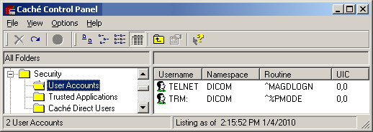
Figure 1 – Caché Control Panel (before edit going into programmer mode)

  - Select TRM:, right click and select Edit. Change the Routine from ^%PMODE to ^MAGDLOGN, and click on OK.
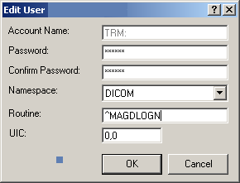
Figure 2 – Caché Control Panel | Edit User

  - You should now see the Routine for TRM: specified as ^MAGDLOGN.
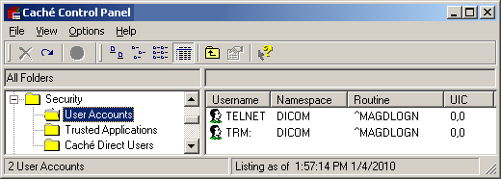
Figure 3 – Caché Control Panel with DICOM Gateway login program

- In the Caché Terminal session, use Edit | Font to set Font to Terminal, Regular, 9 point. Click on OK.
- Use Edit | Window Size to set Columns to 132 and Rows to 48. Click Save.
- Use Edit | Color to change Foreground and Background colors.
- Set Foreground color to White (255, 255, 255)
- Set Background color to Dark Blue (0, 0, Blue=127). You may have to use Adjust Colors.
- Click Save, and Apply

Enabling the Importer
The Importer runs on a DICOM Image Gateway. Before anyone can use the Importer, run menu option 4-2-2 Update Gateway Configuration Parameters to enable it:

Use the IMPORTER instead of "DICOM Correct"? NO// Y

Importer Menus
The Importer is menu option is 2-12 Import DICOM Objects.

VistA DICOM Image Gateway

1 (Receive PACS Exam Complete Messages)
2 (Send PACS Request Image Transfer Messages)
3 Process DICOM Images
4 Increment DICOM Image Input Pointer
5 Display Real-Time Storage Server Statistics
6 Display Cumulative Storage Server Statistics
7 Display Daily Image Processing Statistics
8 Send DICOM Images to Another Storage Server
9 Display a DICOM Image Header
10 Re-Transmit Images from PACS
11 Purge Incomplete Image Information
12 Import DICOM Objects
13 Validate Failed Image Table

OPTION: 12

Import DICOM Objects

1 Import DoD studies that were transmitted directly to the VA
2 Import Outside Contracted studies
3 CD/DVD Import Unordered studies from DoD facilities
4 (CD/DVD Import Unordered studies from other VA facilities)
5 CD/DVD Import Unordered studies from non-VA/DoD facilities
6 Correct local studies with bad PID and/or study information
7 Build Radiology Procedure File
8 Build Radiology Modifiers File
9 Modify Exam/Report Status Update Parameters

OPTION:

The first six options are for importing files, while the last three are for setting up necessary dictionary information.

Use of menu option 4 CD/DVD Import Unordered studies from other VA facilities is unavailable and may be supported in a future patch.

Importer Parameter Setup
Menu option 9 Modify Exam/Report Status Update Parameters is used to establish the parameters that are necessary for advancing the exam status of a study from “Waiting to be Examined” to “Complete” and the report status from “No Report” to “Electronically Filed.”

Import DICOM Objects

1 Import DoD studies that were transmitted directly to the VA
2 Import Outside Contracted studies
3 CD/DVD Import Unordered studies from DoD facilities
4 (CD/DVD Import Unordered studies from other VA facilities)
5 CD/DVD Import Unordered studies from non-VA/DoD facilities
6 Correct local studies with bad PID and/or study information
7 Build Radiology Procedure File
8 Build Radiology Modifiers File
9 Modify Exam/Report Status Update Parameters

OPTION: 9

Modify Exam/Report Status Update Parameters

1 Display Exam/Report Status Update Parameters
2 Modify Radiology Technologist
3 Modify Film Entry
4 Modify Diagnostic Code
5 Modify Camera/Equipment Room
6 Modify CPT Modifier
7 Modify All the above Parameters

OPTION:

Menu option 2 identifies the radiology technologist who normally is involved in the examination process. When an unordered study is imported from the outside, however, this person does not participate in the examination process.

Here is the interaction for setting the Radiologist Technologist parameter:

Modify Exam/Report Status Update Parameters

1 Display Exam/Report Status Update Parameters
2 Modify Radiology Technologist
3 Modify Film Entry
4 Modify Diagnostic Code
5 Modify Camera/Equipment Room
6 Modify CPT Modifier
7 Modify All the above Parameters

OPTION: 2

Enter the Radiology Technologist: O

Select the Radiology Technologist from this list:
1 -- ONESEVEN,PROVIDER
2 -- ONETHREENINESEVEN,PROVIDER
3 -- ONETHREEONE,PROVIDER
4 -- ONETHREETHREE,PROVIDER
5 -- ONETHREEZERO,PROVIDER
6 -- ONETWO,PROVIDER

Enter the number [1-6]: 6

Radiology Technologist changed to "ONETWO,PROVIDER"

Press <Enter> to continue...

Here is the interaction for setting the Film Entry parameter (specify “NO FILMS”):

Modify Exam/Report Status Update Parameters

1 Display Exam/Report Status Update Parameters
2 Modify Radiology Technologist
3 Modify Film Entry
4 Modify Diagnostic Code
5 Modify Camera/Equipment Room
6 Modify CPT Modifier
7 Modify All the above Parameters

OPTION: 3

Enter the Film Size: ?

Select the Film Size from this list:
1 -- 16 x 20
2 -- 4 x 4
3 -- 8 1/2 x 11
4 -- NO FILMS

Enter the number [1-4]: 4

Film Size changed to "NO FILMS"

Press <Enter> to continue...

The Radiology Diagnostic Code has minimal meaning for unordered imported studies. Use a neutral value for this. Here is the interaction for setting the Diagnostic Code parameter (specifying “NO ALERT REQUIRED”):

Modify Exam/Report Status Update Parameters

1 Display Exam/Report Status Update Parameters
2 Modify Radiology Technologist
3 Modify Film Entry
4 Modify Diagnostic Code
5 Modify Camera/Equipment Room
6 Modify CPT Modifier
7 Modify All the above Parameters

OPTION: 4

Enter the Radiology diagnostic code: ?

Select the Radiology diagnostic code from this list:
1 -- ABNORMALITY, ATTN. NEEDED
2 -- CRITICAL ABNORMALITY
3 -- MAJOR ABNORMALITY, NO ATTN. NEEDED
4 -- MAJOR ABNORMALITY, PHYSICIAN AWARE
5 -- MINOR ABNORMALITY
6 -- NO ALERT REQUIRED
7 -- NORMAL
8 -- POSSIBLE MALIGNANCY
9 -- POSSIBLE MALIGNANCY, FOLLOW-UP NEEDED
10 -- SIGNIFICANT ABNORMALITY, ATTN NEEDED
11 -- TELERADIOLOGY, NOT YET DICTATED
12 -- UNDICTATED FILMS NOT RETURNED, 3 DAYS
13 -- UNSATISFACTORY/INCOMPLETE EXAM

Enter the number [1-13]: 6

Radiology diagnostic code changed to "NO ALERT REQUIRED"

Press <Enter> to continue...

Always use “OUTSIDE STUDY” for the Camera/Equipment/Room (see Appedix). Here is the interaction for setting this parameter:

Modify Exam/Report Status Update Parameters

1 Display Exam/Report Status Update Parameters
2 Modify Radiology Technologist
3 Modify Film Entry
4 Modify Diagnostic Code
5 Modify Camera/Equipment Room
6 Modify CPT Modifier
7 Modify All the above Parameters

OPTION: 5

Enter the Camera/Equipment/Room: ?

Select the Camera/Equipment/Room from this list:
1 -- OUTSIDE STUDY (Study performed outside of this facility)
2 -- PORTABLE (MOBILE PICTURES)
3 -- TD RAD-EXAM1 (This is the primary x-ray room.)
4 -- TD RAD-EXAM2 (Sonograms are done in this room.)
5 -- TD RAD-EXAM3 (Endoscopies are done in this room.)

Enter the number [1-5]: 1

Camera/Equipment/Room changed to "OUTSIDE STUDY"

Press <Enter> to continue...

The CPT modifier has minimal meaning for unordered imported studies. Use a neutral value for this. Here is the interaction for setting the CPT Modifier parameter (specifying “TECHNICAL COMPONENT”):

Modify Exam/Report Status Update Parameters

1 Display Exam/Report Status Update Parameters
2 Modify Radiology Technologist
3 Modify Film Entry
4 Modify Diagnostic Code
5 Modify Camera/Equipment Room
6 Modify CPT Modifier
7 Modify All the above Parameters

OPTION: 6

Enter the CPT Modifier: T

Select the CPT Modifier from this list:
1 -- TECHNICAL COMPONENT
2 -- TEL (LEUKEMIA)
3 -- TFE3 OR ASPSCR1 (ALVEOLAR SO
4 -- THIRD/MORE CONCURRENTLY ADMIN INFUSION THERAPY
5 -- THREE PATIENTS SERVED
6 -- TP53, COMMONLY CALLED P53
7 -- TPMT (THIOPURINE METHYLTRANS
8 -- TRB, T CELL RECEPTOR BETA (L
9 -- TRG, T CELL RECEPTOR GAMMA (
10 -- TWIST (SAETHRE-CHOTZEN SYNDR
11 -- TWO CLASS B FINDINGS
12 -- TWO PATIENTS SERVED
13 -- TWO SURGEONS

Enter the number [1-13]: 1

CPT Modifier changed to "TECHNICAL COMPONENT"

Press <Enter> to continue...

All of the current parameter values may be displayed using menu option 1 Display Exam/Report Status Update Parameters, as shown below:

Modify Exam/Report Status Update Parameters

1 Display Exam/Report Status Update Parameters
2 Modify Radiology Technologist
3 Modify Film Entry
4 Modify Diagnostic Code
5 Modify Camera/Equipment Room
6 Modify CPT Modifier
7 Modify All the above Parameters

OPTION: 1

Radiology Technologist(*): ONETWO,PROVIDER
Film Size(*): NO FILMS
Radiology diagnostic code(*): NO ALERT REQUIRED
Camera/Equipment/Room(*): OUTSIDE STUDY
CPT Modifier: TECHNICAL COMPONENT

Fields with an asterisk (*) require values.

Press <Enter> to continue...

Setting up Outside Imaging Locations for the DICOM Importer – See Appendix A

Running the Importer from Remote Desktop – See Appendix B

Handling Parent-Descendent Procedure Orders with the Importer – See Appendix C

Problems Seen in Importing of DICOM Objects from Media – See Appendix D

Using the BATCH_SEND_IMAGE.BAT utility script – See Appendix E

Importer Session Operation
The Importer can handle ordered and unordered (prior) studies that are received from direct transmissions or loaded from portable media (CD/DVD). These studies can come from the DoD, a contracted facility, a different VA, or another institution.

The first six Importer menu options specify the operation of the Importer session.

Import DICOM Objects

1 Import DoD studies that were transmitted directly to the VA
2 Import Outside Contracted studies
3 CD/DVD Import Unordered studies from DoD facilities
4 (CD/DVD Import Unordered studies from other VA facilities)
5 CD/DVD Import Unordered studies from non-VA/DoD facilities
6 Correct local studies with bad PID and/or study information
7 Build Radiology Procedure File
8 Build Radiology Modifiers File
9 Modify Exam/Report Status Update Parameters

If a directly transmitted DICOM object fails association because of Patient Name, Patient ID, and/or Accession Number mismatch, menu options 1 and 6 may be used to import these studies. (Menu option 2 may also be used if the outside studies were transmitted from the contracted facility to the VA).

Note: The VistA hospital information system DISPLAY STUDIES TO BE IMPORTED option on the IMPORTER menu may be used to view each gateway’s list of the transmitted studies that are waiting to be imported.

If the studies are obtained from portable media, menu options 2, 3, 4, and 5 may be used to import their DICOM objects.

The Importer session is divided into two parts, a manual interactive part followed by an automated non-interactive part. In the interactive part, the user selects the studies that are to be imported and defines the association between them and patient and study entities on VistA. In the non-interactive part, the necessary radiology studies are ordered and/or have their status updated, reconciliation takes place, and images are imported, all without any user involvement.

The following two diagrams give high level views of the Importer workflow. Figure 4 – VA Import Reconciliation Workflow is a very high level view of the Importer application. Figure 5 – High Level Importer Workflow illustrates the two major parts of the Importer session. The manual interactive part of the Importer session is “Study Selection and Association” while the automatic part consists of the “Automatic Study Ordering” and “Import Reconciliation” steps.

VA Import Reconciliation Workflow

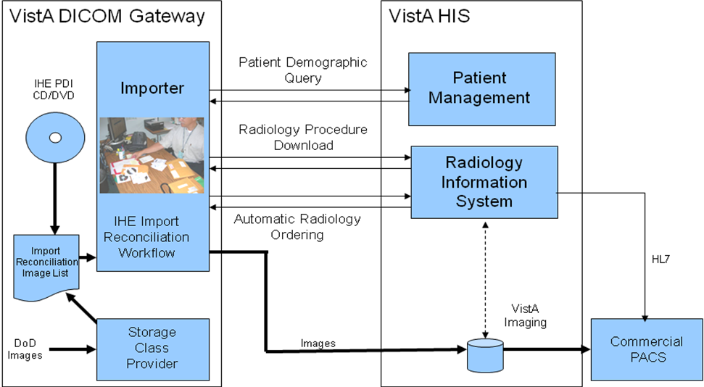

Figure 4 – VA Import Reconciliation Workflow
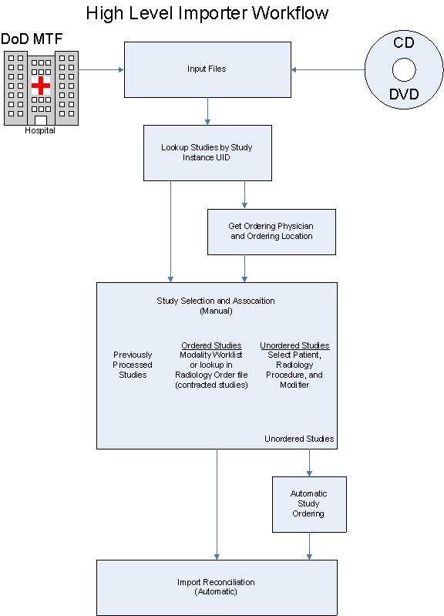
Figure 5 – High Level Importer Workflow

Importer Session – Ordered Study Workflow

Import DICOM Objects

1 Import DoD studies that were transmitted directly to the VA
2 Import Outside Contracted studies
3 CD/DVD Import Unordered studies from DoD facilities
4 (CD/DVD Import Unordered studies from other VA facilities)
5 CD/DVD Import Unordered studies from non-VA/DoD facilities
6 Correct local studies with bad PID and/or study information
7 Build Radiology Procedure File
8 Build Radiology Modifiers File
9 Modify Exam/Report Status Update Parameters

There are two Importer options for the processing of ordered studies. The first option (#2) is used to import studies from an outside contracted facility and the other option (#6) is used for correcting local studies with erroneous patient and/or study identification information. The workflow for these two Importer options is identical. (The only difference is that the Imaging file (#2005) field ORIGIN INDEX is “F” for the fee basis contracted studies and “V” for the corrected ones.)

Studies that are to be imported are selected from a list and matched to ordered studies on VistA. After this is done, import reconciliation is performed and they are imported.

Importer Study Selection

The Importer Study Selection is used for all imported studies, regardless if they were previously ordered or not, or whether they were directly acquired or obtained from portable media. This workflow allows the user to select importable DICOM studies and match them to existing studies (ordered case) or VistA patients and equivalent procedures (unordered case).

The list of importable DICOM studies is created from either data in the DICOM directory file (DICOMDIR) or from the DICOM objects that have been directly acquire via the network. The list is hierarchically organized. For each study in the list there is an entry for each DICOM series, and within each DICOM series there is an entry for each DICOM object.

The interactive study selection and order association process for both ordered and unordered studies is illustrated below in Figure 6 – Study Selection and Association.
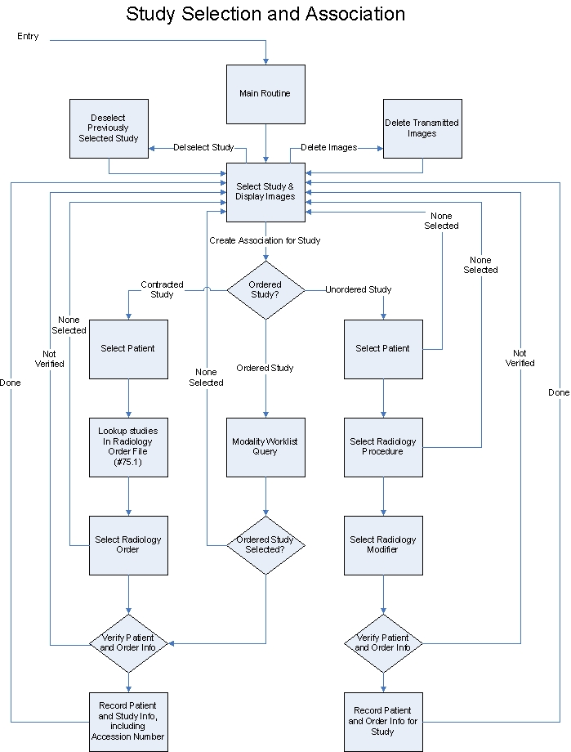
Figure 6 – Study Selection and Association

Initial Checking of DICOM Studies
Prior to constructing the list of importable DICOM studies, those DICOM objects that have already been imported are identified and non-supported DICOM objects are flagged. (For more information, see section 3.4 Details of Study Checking at the end of this chapter.)

Importer Study Selection Screen
The Study Selection screen is presented to the user after checking has been performed and any associated warning messages have been displayed.

The following fields are displayed for each study:
- Selection Number – 1:n, identifies study so that it can be selected
- Patient ID
- Patient Name
- Patient DOB
- Patient Sex
- Accession Number
- Study Date
- Study Description
- Number of images, by modality

Figure 7 – Importer Study Selection Screen is an example, using the anonymized patients from the public domain American Dental Association (ADA) 2006 DICOM CD.

Import Studies that were Ordered by the VA and Contracted to be Performed on the Outside
----------------------------------------------------------------------------------------

# Patient ID Patient Name Birth Sex Accession Number Date Description Images
--- -------------- ------------------------------ ---------- --- ---------------- -------- ------------ ------
1) 000-00-0001 OUTSIDE-1,PATIENT-1 02/01/2002 M 02/20/05 DX=1
2) 000-00-0001 OUTSIDE-1,PATIENT-1 02/01/2002 M 01/04/05 IO=1
3) 000-00-0001 OUTSIDE-1,PATIENT-1 02/01/2002 M 07/03/05 IO=1
4) 000-00-0001 OUTSIDE-1,PATIENT-1 02/01/2002 M 03/17/05 PX=1
5) 000-00-0001 OUTSIDE-1,PATIENT-1 02/01/2002 M 06/22/06 XC=1
6) 000-00-0002 OUTSIDE-2,PATIENT-2 01/01/1900 F 000000037 07/05/05 Bite Wing X-Ray IO=2 PX=1
7) 000-00-0003 OUTSIDE-3,PATIENT-3 12/24/1948 M 03/06/05 IO=3 XC=2
8) 000-00-0003 OUTSIDE-3,PATIENT-3 12/24/1948 M 06/20/06 IO=4 XC=3
9) 000-00-0003 OUTSIDE-3,PATIENT-3 12/24/1948 M 04/17/06 IO=3 PX=1 XC=3
10) 000-00-0004 OUTSIDE-4,PATIENT-4 08/04/2006 O 08/04/06 DX=1 IO=2 PX=1
11) 000-00-0005 OUTSIDE-5,PATIENT-5 05/13/2005 M 1 05/13/05 OCD Digital X-ray DX=1
12) 000-00-0006 OUTSIDE-6,PATIENT-6 05/13/2005 M 1 05/13/05 Sigma Digital X-ray IO=1
13) 000-00-0006 OUTSIDE-6,PATIENT-6 05/13/2005 M 1 05/13/05 Sigma Digital X-ray IO=1
14) 000-00-0007 OUTSIDE-7,PATIENT-7 12/05/2000 M 1 05/13/05 OPD Digital X-ray PX=1
15) 000-00-0007 OUTSIDE-7,PATIENT-7 12/05/2000 M 1 05/13/05 OPD Digital X-ray PX=1
16) 000-00-0008 OUTSIDE-8,PATIENT-8 01/01/2006 F 007 06/07/06 Sample for ADA 2006 DX=1
17) 000-00-0008 OUTSIDE-8,PATIENT-8 01/01/2006 F 007 06/07/06 Sample for ADA 2006 IO=1
18) 000-00-0008 OUTSIDE-8,PATIENT-8 01/01/2006 F 007 06/07/06 Sample for ADA 2006 PX=1
19) 000-00-0008 OUTSIDE-8,PATIENT-8 01/01/2006 F 007 07/20/06 Sample for ADA 2006 OT=1
20) 000-00-0008 OUTSIDE-8,PATIENT-8 01/01/2006 F 007 07/20/06 Sample for ADA 2006 XC=1
21) 000-00-0009 OUTSIDE-9,PATIENT-9 11/02/1955 F 20 01/17/05 Cosmetic series vid XC=3
22) 000-00-0009 OUTSIDE-9,PATIENT-9 11/02/1955 F 35 03/28/05 2 PA IO=2
23) 000-00-0009 OUTSIDE-9,PATIENT-9 11/02/1955 F 36 03/28/05 PA IO=1
24) 000-00-0009 OUTSIDE-9,PATIENT-9 11/02/1955 F 18 01/17/05 Panoramic PX=1
25) 000-00-0010 OUTSIDE-10,PATIENT-10 02/14/1972 M 1432 04/15/05 ProMax Ceph DX=1
26) 000-00-0010 OUTSIDE-10,PATIENT-10 02/14/1972 M 1 04/15/05 Planmeca images IO=2 PX=1
27) 000-00-0011 OUTSIDE-11,PATIENT-11 08/07/1970 M 08/08/06 IO=1
28) 000-00-0011 OUTSIDE-11,PATIENT-11 08/07/1970 M 08/08/06 IO=1
29) 000-00-0011 OUTSIDE-11,PATIENT-11 08/07/1970 M 08/08/06 IO=1
30) 000-00-0011 OUTSIDE-11,PATIENT-11 08/07/1970 M 08/08/06 IO=1
31) 000-00-0012 OUTSIDE-12,PATIENT-12 01/01/2000 M 03/17/06 FULL MOUTH SERIES ( IO=1
32) 000-00-0012 OUTSIDE-12,PATIENT-12 01/01/2000 M 03/03/06 FULL MOUTH SERIES ( IO=1
33) 000-00-0012 OUTSIDE-12,PATIENT-12 01/01/2000 M 03/29/06 FULL MOUTH SERIES ( IO=1
34) 000-00-0012 OUTSIDE-12,PATIENT-12 01/01/2000 M 06/14/06 PANO 1x2 PX=1
35) 000-00-0013 OUTSIDE-13,PATIENT-13 03/11/2005 08/04/06 ADA DICOM CD DX=1 IO=1 PX=2
36) 000-00-0014 OUTSIDE-14,PATIENT-14 O 12/16/05 IO=2
37) 000-00-0015 OUTSIDE-15,PATIENT-15 11/23/1963 O 10/20/05 Study 10/20/2005 DX=1
38) 000-00-0015 OUTSIDE-15,PATIENT-15 11/23/1963 O 07/06/06 Study 7/6/2006 ES=1
39) 000-00-0015 OUTSIDE-15,PATIENT-15 11/23/1963 O 05/26/06 Study 5/26/2006 IO=1
40) 000-00-0015 OUTSIDE-15,PATIENT-15 11/23/1963 O 10/05/05 Study 10/5/2005 PX=1

Please enter the next study to import or enter “C” to continue:
Figure 7 – Importer Study Selection Screen

Importer Study Selection Interaction
The user is prompted to enter a study number.

Please enter study to import or enter “C” to continue:

The user may either enter the number of a study (in this case 1 to 40) or may enter a “C” to conclude the manual study selection/order association step and continue with the automatic import reconciliation step.

If the user enters a “C” to continue with the next step, the user is asked if the DICOM objects are now to be imported.

Ready to import the DICOM objects? n // Y

If the user enters YES, the automatic importation process begins (see 3.1.4 for details). Control is passed back to the Importer menu when it is completed.

Ready to import the DICOM objects? n // n

If the user enters NO, the importation process is skipped and the user is asked if they wish to exit the Importer session.

Exit the application and not import the DICOM objects? n //

If the user enters YES, the Importer session is closed and control is passed back to the Importer menu. If the user answers NO, the Importer session continues and control is passed back to the Study Selection screen.

Series and Image Selection and Display
Let’s assume that the user selects Study 9 and wants to view the images.

When the study is selected, detailed study information is presented to the user along with three options, select the study, view images of the study, or skip the study and select another one.

Please enter the next study to import or enter “C” to continue: 9

Patient Name: OUTSIDE-3,PATIENT-3 Patient ID: 000-00-0003 Birth Date: Dec 24, 1948 Sex: M
Accession #: Study Date: 04/17/06 Study Time: 01:00:00 am
Study Instance UID: 2.16.840.1.114059.1.19481224.20060417

Is this the correct study/view images? [enter Y, N, R] v// ?

Please enter one of the following options:
Yes -- when you are ready to assign this study to a patient
No -- if you want to skip this study and select a different one
View -- when you want to display the DICOM objects for this study

Is this the correct study/view images? [enter Y, N, R] v//

The user is prompted to enter an action.

Is this the correct study/view images? [enter Y, N, R] v//

The default is “v” for view. If the user selects “n”, control is passed back to the previous study selection screen without any further action. (The “selected study” is still available for selection.)

Let’s assume that the user enters “v” for view. The following information is displayed:

Please enter study to import or press <Enter> to continue: 9

Patient Name: OUTSIDE-3,PATIENT-3 Patient ID: 000-00-0003 Birth Date: Dec 24, 1948 Sex: M
Accession #: Study Date: 04/17/06 Study Time: 01:00:00 am
Study Instance UID: 2.16.840.1.114059.1.19481224.20060417

Is this the correct study/view images? [enter Y, N, R] v// v

Series 1 contains 3 XC files
Series 2 contains 3 IO files
Series 3 contains 1 PX file

Acquisition site: DEXIS Demo Practice

There are 3 Series in this Study. Enter a series number:

If there are more than one series in the study, the user is prompted to enter the series number. (There is no prompt if there is only one series.)

There are 3 Series in this Study. Enter a series number:

This study contains three series, Series 1 with three External Camera (modality = XC) images, Series 2 with three Inter Oral (modality = IO) images, and Series 3 with one Panoramic x-ray image (modality = PX). The user may select any series and see its images. If the user enters a null series number, control is passed back to the previous “Is this the correct study/view images?” prompt.

Let’s assume that the user entered “2” to see the images for Series 2. The following information would be displayed:

There are 3 Series in this Study. Enter a series number: 2

There are 3 Images in Series 2. Enter an image number:

If there is more than one image in the series, the user is prompted to enter the image number. (There is no prompt if there is only one image.)

There are 3 Images in Series 2. Enter an image number:

The user may select any image to view. If the user enters a null image number, control is passed back to the previous “Enter a series number:” prompt.

A sequence of images may be entered in <first image #> - <last image #> format, for example “1-3”.

Let’s assume that the user entered just “1” to see the first image.

There are 3 Images in Series 2. Enter an image number: 1

Control is immediately passed to the VistA DICOM Viewer (see Figure 8 – Dental Image).

The user can manipulate the image using the viewer or can switch between images if a sequence of images is selected. Control is passed back to the Importer when the user closes the viewer window. If there is more than one image for the series, the user is again presented with the “Enter an image number:” prompt and allowed to view additional images from the series.

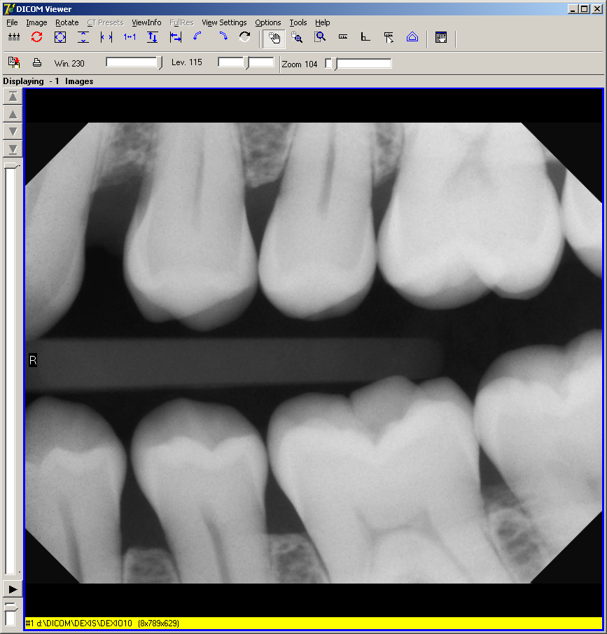
Figure 8 – Dental Image

Associating the Selected Study with an Ordered Study
After the outside study has been selected is must be associated with an ordered study on VistA. This example illustrates obtaining this information from VistA using a DICOM Modality Worklist. (See the next section 3.1.3 for another way to associate an outside contracted radiology study with the order on VistA.)

When the user selects a study and enters “Y” at the “Is this the correct study/view images?” prompt, control will be passed to the Modality Worklist subroutine. (It is assumed that this is not a contracted radiology study and that menu option 2-12-2 Import Outside Contracted studies is not being used.)

Please enter the next study to import or enter “C” to continue: 9

Patient Name: OUTSIDE-3,PATIENT-3 Patient ID: 000-00-0003 Birth Date: Dec 24, 1948 Sex: M
Accession #: Study Date: 04/17/06 Study Time: 01:00:00 am
Study Instance UID: 2.16.840.1.114059.1.19481224.20060417

Is this the correct study/view images? [enter Y, N, V] v// y

The user must select the site’s “Local Modality Worklist” as the DICOM Modality Worklist Query Service Class Provider. (The list itself will depend upon the entries in the site’s SCU_LIST.DIC.)

Modality Worklist Query
DICOM Service Class Providers
-----------------------------
1 -- CR1 STORAGE SCP
2 -- LOCAL MODALITY WORKLIST

Select the provider application (1-2): 2

The user will then need to select the proper Application Entity Title for the study (as defined in WORKLIST.DIC.)

Select the Application Entity Title: RAD

The user should know the VistA patient id and accession number for the ordered study. Enter these as the Modality Worklist Attribute Key values. (The following example shows an accession number query.)

SELECT MODALITY WORKLIST ATTRIBUTE KEYS
---------------------------------------
PATIENT NAME (1) :

PATIENT ID (2) :

ACCESSION NUMBER (3) :

REQUESTED PROCEDURE ID (4) :

MODALITY (5) :

START DATE (6) :

START TIME (7) :

Enter 1-7 to change an item above, "R" to refresh, "Q" to query: 3

Enter the Accession Number or the Case Number: 040909-341

Then enter “Q” to begin the query:

SELECT MODALITY WORKLIST ATTRIBUTE KEYS
---------------------------------------

PATIENT NAME (1) :

PATIENT ID (2) :

ACCESSION NUMBER (3) : 040909-341

REQUESTED PROCEDURE ID (4) :

MODALITY (5) :

START DATE (6) :

START TIME (7) :

Enter 1-7 to change an item above, "R" to refresh, "Q" to query: q
Performing Query...
Sending the PDU to the SOP Class Provider via TCP
completed!

One match should be returned. Here is an example:

Patient Name: PATIENT,FOURONEZERO Race: <unknown>
Patient Sex: M Status: OUTPATIENT Pregnancy Status: Not Pregnant
Patient Identifier: 000-00-0410 ICN/MPI: 9810937512V654749
Admission ID: <unknown> Issuer of Patient ID: USVHA
Patient Height: <unknown> Patient Weight: <unknown>
Date of Birth: 1 January 1924 Location: <unknown>
Address: 605 MORSE STREET, SALT LAKE CITY, UT 32650
Confidentiality: <unknown> Institution: SALT LAKE CITY

Accession Number: 040909-341 Requested Proc ID: 341
VA Procedure Code: 58 Name: CHEST 2 VIEWS PA&LAT
CPT Code: 71020 Name: CHEST X-RAY
Scheduled: 9 April 2009 at 08:23:04 in RAD Status: SCHEDULED
Requesting Physician: IMAGPROVIDERONETWOSIX,ONETWOSIX Priority: ROUTINE
Call Back Number: (301)734-0100
Requesting Service: CARDIOLOGY Attention: <unknown>
Referring Physician: IMAGPROVIDERONETWOSIX,ONETWOSIX
Study UID: 1.2.840.113754.1.40.660.6909590.9177.1.660.40909.341
Reason for Study: TESTING AGAIN

------------------------------- Medical History -----------------------------
Reason for Study: TESTING AGAIN

MORE OF THE SAME
-----------------------------------------------------------------------------
Study Comments:

Is this the correct Patient and Study? n//

If the user enters “No” at the “Is this the correct Patient and Study?” prompt, control will be returned to the Study Selection screen.

If the user enters “Yes” at the prompt, a verification screen will be presented.

Is this the correct Patient and Study? n// y

Imported File VistA
------------- -----
Patient Name: OUTSIDE-3,PATIENT-3 PATIENT,FOURONEZERO
Patient ID: 000-00-0003 000-00-0410
Date of Birth: 12/24/1948 01/01/1924
Patient Sex: M M
Accession Number: 040909-341
Study Date: 04/17/06 04/09/09 (scheduled date)
Procedure: TEETH PARTIAL EXAM

Is this the correct patient/study/procedure from VistA? N //

If the user enters “No” at the “Is this the correct patient/study/procedure from VistA?” prompt, control will be returned to the Study Selection screen.

If the user enters “Yes” at the prompt, s/he will be asked if a VA Radiologist will be reading the study (assuming that this is a radiology study and not a consult).

Is this the correct patient/study/procedure from VistA? N // y

Will a VA Radiologist read this study? N // N

If a VA Radiologist is going to read the study, the Exam Status will be set to “Examined” and the Report Status will be set to “No Report”. (The study will also be placed on a VistARad reading worklist.)

If a VA Radiologist is not going to read the study, the Exam Status will be set to “Complete” and Report Status will be set to “Electronically Filed”.

Control will then return to the Study Selection screen.

Each study that is to be imported is then identified with a lower-case green “i” on the Study Selection screen, like below:

8)i 000-00-0003 OUTSIDE-3,PATIENT-3

Associating an Outside Contracted Study with the Order on VistA
Import DICOM Objects

1 Import DoD studies that were transmitted directly to the VA
2 Import Outside Contracted studies
3 CD/DVD Import Unordered studies from DoD facilities
4 (CD/DVD Import Unordered studies from other VA facilities)
5 CD/DVD Import Unordered studies from non-VA/DoD facilities
6 Correct local studies with bad PID and/or study information
7 Build Radiology Procedure File
8 Build Radiology Modifiers File
9 Modify Exam/Report Status Update Parameters

Contracted outside studies are entered using menu option 2-12-2 Import Outside Contracted studies.

The order for a contracted radiology study can be obtained directly from the Radiology Order file (#75.1) on VistA. (See the previous section 3.1.2 for obtaining VistA patient and study information via DICOM Modality Worklist.) The radiology order on VistA will be automatically be registered, if need be, as part of the import reconciliation process. The auto-registration process will use the actual date and time of the study so that the VistA radiology order is created in the database in the chronologically correct sequence.

For a contracted radiology study, when the user selects a study and enters “Y” at the “Is this the correct study/view images?” prompt, s/he will be asked how to lookup the study on VistA.

Is this the correct study/view images? [enter Y, N, V] v// y

Use Modality Worklist or look up in Radiology Order file r // ?
Please enter "Modality Worklist", or "Radiology Order file".

Use Modality Worklist or look up in Radiology Order file r //

If the user enters “m”, control will be passed to the Modality Worklist subroutine, as described in the previous section 3.1.2. Let’s assume instead that the user enters “R” (or took the default) so that the study will be selected from the Radiology Order file (#75.1).

In order to search the Radiology Order file, the user must first identify the VA patient. The patient is selected exactly as it is in CPRS. The following example shows the short id being used to pick the patient:

Enter VA Patient: P1023

Patient ID VA Patient Name Birth Sex
-------------- ------------------------------ ---------- ---
000-00-1023 PATIENT,ONEZEROTWOTHREE 02/04/1944 M

Is this the correct patient? No // y

Once the patient is selected, the list of active (registered) and pending (not registered) studies is displayed (see Figure 9 – Radiology Order File Lookup Screen below). The user selects the one that corresponds to the contracted outside study.

The user is asked to verify the selection and then control is passed back to the study selection screen. The study that is to be imported will again be identified with a lower-case green “i” on the Study Selection screen.
VistA Radiology Orders PATIENT,ONEZEROTWOTHREE 000-00-1023
--------------------------------------------------------------------

# Status Ordered Procedure Reason for Study Accession #
---- -------- -------- ---------------------------------------- ---------------------------------------- -----------
1) ACTIVE 08/08/98 CHEST 2 VIEWS PA&LAT -------------------- ----------------------------------------- 660-070505-400
2) ACTIVE 08/21/98 ABDOMEN 1 VIEW -------------------------- ----------------------------------------- 660-070505-401
3) ACTIVE 08/21/98 HAND 1 OR 2 VIEWS ----------------------- ----------------------------------------- 660-070505-409
4) PENDING 08/21/98 CHEST 2 VIEWS PA&LAT -------------------- -----------------------------------------
5) ACTIVE 08/04/99 ABDOMEN 1 VIEW -------------------------- ----------------------------------------- 660-070505-405
6) ACTIVE 01/23/01 ABDOMEN 1 VIEW -------------------------- ----------------------------------------- 660-070505-406
7) PENDING 01/23/01 CHEST 2 VIEWS PA&LAT -------------------- -----------------------------------------
8) ACTIVE 02/21/02 CHEST 2 VIEWS PA&LAT -------------------- ----------------------------------------- 022102-104
9) ACTIVE 01/13/04 CHEST SINGLE VIEW ----------------------- ----------------------------------------- 011304-261
10) ACTIVE 04/29/05 CHEST 2 VIEWS PA&LAT -------------------- ----------------------------------------- 042905-262
11) ACTIVE 05/02/05 CHEST 2 VIEWS PA&LAT -------------------- ----------------------------------------- 050205-260
12) ACTIVE 12/27/04 CHEST 2 VIEWS PA&LAT -------------------- ----------------------------------------- 122704-263
13) ACTIVE 10/23/08 HAND 1 OR 2 VIEWS ----------------------- broken ---------------------------------- 102308-310
14) ACTIVE 10/23/09 CHEST 2 VIEWS PA&LAT -------------------- TESTING NEW RADIOLOGY FUNCTION ---------- 660-102309-390

Please enter the corresponding study: 7

#7 Status: PENDING Ordered: 01/23/01 04:28:35 pm Accession Number: Study Date:
Procedure Name: CHEST 2 VIEWS PA&LAT Procedure Number: 58
Modifier(s):
Reason for Study:

Is this the correct study? y // y

Imported File VistA
------------- -----
Patient Name: DENTRIX,VIPERSOFT PATIENT,ONEZEROTWOTHREE
Patient ID: 801-763-9300 000-00-1023
Date of Birth: 01/01/1900 02/04/1944
Patient Sex: F M
Accession Number: 000000037 (automatically generated)
Study Date: 07/05/05 (will be set to same date)
Procedure: Bite Wing X-Ray CHEST 2 VIEWS PA&LAT

Is this the correct patient/study/procedure from VistA? N // y

Figure 9 – Radiology Order File Lookup Screen

Importing the Ordered Study into VistA
When the user has selected all of the studies that need to be imported, s/he should enter a “C” to the “Please enter the next study to import or enter “C” to continue:” prompt. This will conclude study selection and proceed to the import reconciliation step.

The user will be asked if the DICOM objects are now to be imported.

Ready to import the DICOM objects? n // Y

If the user enters YES, the automatic importation process begins. Control is passed back to the Importer menu when it is completed.

(If the user enters NO, the importation process is skipped and s/he is asked if they wish to exit the Importer session or return to the Study Selection screen.)

Import reconciliation is entirely automatic. The studies are listed as they are being imported. Here is an example of the output:

Please enter study to import:

Ready to import the DICOM objects? n // y

Importing Study #8 for Patient PATIENT,SIXZERO ID: 000-00-0060
Source: Accession Number: 021009-323
.......
*****************************************************************************
*** Import Complete -- Please remove the CD/DVD disk from the d: drive. ***
*****************************************************************************

Press <Enter> to continue...

The DICOM objects are updated with the correct patient and study information from VistA and are placed onto the Image Input queue of the Gateway. Menu option 2-3 Image Processing must be run to load them into VistA.

Imported DICOM objects do not need to have corresponding entries in MODALITY.DIC. By default, they are loaded into VistA in DICOM format.

Deleting (not Importing) Transmitted DICOM Studies
Let’s assume that a set of dummy images were acquired for a test study and were transmitted to the DICOM gateway. This test study appears on the list of importable DICOM studies and needs to be deleted.

When the user selects a transmitted study, there are four options that can be used. In addition to the three options listed in previous section 3.1.1.4, there is also an option to delete the study. (This option is not necessary for DICOM studies being imported from portable media.)
Import DoD DICOM Studies that were Transmitted to the VA
--------------------------------------------------------

# Patient ID Patient Name Birth Sex Accession Number Date
--- -------------- ------------------------------ ---------- --- ---------------- --------
1) 000-00-0016 OUTSIDE-16,PATIENT-16 03/04/1960 F 030498-12345 03/19/97

Please enter the next study to import or enter "C" to continue: 1

Patient Name: OUTSIDE-16,PATIENT-16 Patient ID: 000-00-0016 Birth Date: Mar 4, 1960 Sex: F Accession #: 030498-12345 Study Date: 03/19/97 Study Time: 11:47:19 am Referring Physician: Physician,Referring
Study Instance UID: 2.16.840.1.113662.2.1.486876813333.429.33.100100
Sent by Calling AE Title: DICOM_TEST

Is this the correct study/view images (or delete the study)? [enter Y, N, V (or DEL)] v// ?
Please enter one of the following options:
Yes -- when you are ready to assign this study to a patient
No -- if you want to skip this study and select a different one
View -- when you want to display the DICOM objects for this study
DELete -- should you want to delete this study (you must use "DEL")

Is this the correct study/view images (or delete the study)? [enter Y, N, V (or DEL)] v// del

Are you sure that you want to delete this study and not import it into VistA? n // y

Each study that is to be deleted is then identified with a lower-case green “d” on the Study Selection screen, like below:

1)d 000-00-0016 OUTSIDE-16,PATIENT-16

The final prompt indicates that DICOM objects will be deleted.
Ready to delete the DICOM objects? n // Y
Deleting #1 .

Press <Enter> to continue...
The DICOM objects are removed from the C:\DICOM\IMAGE_IN folder and from the list of importable DICOM studies.

Correcting Images with Erroneous Patient/Study Identification

Import DICOM Objects

1 Import DoD studies that were transmitted directly to the VA
2 Import Outside Contracted studies
3 CD/DVD Import Unordered studies from DoD facilities
4 (CD/DVD Import Unordered studies from other VA facilities)
5 CD/DVD Import Unordered studies from non-VA/DoD facilities
6 Correct local studies with bad PID and/or study information
7 Build Radiology Procedure File
8 Build Radiology Modifiers File
9 Modify Exam/Report Status Update Parameters

DICOM studies from local modalities that have failed to be associated because of erroneous patient and/or study identification can be corrected and imported by the above method. Use menu option 6 Correct local studies with bad PID and/or study information.

Importer Session – Unordered Study Workflow
An unordered study is one that is unknown to the local VistA system. It may have been performed while the patient was being treated at an outside facility and then was then sent to the local VA when the patient was going there for treatment. For example, a service person has some studies performed in the DoD and then comes to the VA for additional treatment. The DICOM images from the DoD need to be imported into VistA.

Import DICOM Objects

1 Import DoD studies that were transmitted directly to the VA
2 Import Outside Contracted studies
3 CD/DVD Import Unordered studies from DoD facilities
4 (CD/DVD Import Unordered studies from other VA facilities)
5 CD/DVD Import Unordered studies from non-VA/DoD facilities
6 Correct local studies with bad PID and/or study information
7 Build Radiology Procedure File
8 Build Radiology Modifiers File
9 Modify Exam/Report Status Update Parameters

There are four Importer options for the processing of unordered studies. The first option (#1) is used to import studies that were transmitted from the DoD to the VA, like for studies sent from National Naval Medical Center to a VA Polytrauma Center. The other three (#3, #4, and #5) are used to import DICOM objects from portabile media. The workflow for these four Importer options is identical. (The only differences are the source of the DICOM objects and that the Imaging file (#2005) field ORIGIN INDEX is “D” for DoD studies, “V” for VA ones and “N” for the other facilities.)

For the unordered study to be imported into VistA, a new VistA Radiology order needs to be created for it. The corresponding VistA Radiology procedure for the new order should be one that closely matches the procedure that was originally performed. This is necessary so that the study is properly indexed for later lookup. The Importer user needs to choose the appropriate VistA Radiology procedure. To be able to perform this function, the Importer user should be familiar with radiology procedures in general and have a good working knowledge of VistA Radiology procedures.

When an unordered outside radiology study is to be imported into VistA, an order is automatically placed for it during the import reconciliation step. The VistA order created for the outside radiology study should not accrue workload statistics for VA technical or professional components because the exam was neither performed in the VA nor interpreted by the VA. For this reason, the order created on VistA should use a Radiology imaging location with a CREDIT METHOD = No Credit. This should have been setup by a Radiology/Nuclear Medicine ADPAC (see the Appendix A for details).

Ordering Provider and Ordering Location
At the start of each unordered study Importer session, the user is required to designate an Ordering Provider and Ordering Location that is used for every VistA Radiology order that is created. The site needs to establish a policy for specifying these. One strategy might be (1) for a Polytrauma patient transferred from DoD to the VA, the Ordering Provider is the Chief of the Polytrauma Center and the Ordering Location is the Polytrauma Ward, and (2) for any other patient, the Ordering Provider is the Primary Care Provider and the Ordering Location is the clinic or ward where the patient is being treated.

Here is an example of the interaction:

Ordering Provider: i
1 IMAGPROVIDERFIVEEIGHT,FIVEEIGH
2 IMAGPROVIDERFIVEEIGHT,FIVEEIGHT
3 IMAGPROVIDERFIVETWO,FIVETWO
4 IMAGPROVIDERONEEIGHT,ONEEIGHT
5 IMAGPROVIDERONEFOUR,ONEFOUR
Choose 1-5: 1 IMAGPROVIDERFIVEEIGHT,FIVEEIGH

CORRECT? Y//:

Importer Study Selection
The study selection process for unordered studies is exactly like that for ordered studies (see previous section 3.1.1 for details).

Identifying the VistA Patient
Once the study has been chosen, the user must identify the VA patient for the study. The patient is selected exactly as it is in CPRS. The following example shows the short id being used to pick the patient:

Enter VA Patient: P0410

Patient ID VA Patient Name Birth Sex
-------------- ------------------------------ ---------- ---
000-00-0410 PATIENT,FOURONEZERO 00/00/1924 M

Is this the correct patient? No // Y

Selecting the Corresponding VistA Radiology Procedure
After the VA patient has been identified, the user is asked to select the equivalent VistA Radiology procedure that most closely corresponds to the one that was originally performed for the study. This may require the user to view the studies images in order to properly determine the appropriate VistA Radiology procedure. The user may also designate procedure modifier(s).

Enter Procedure: tee

Please select one of the following:
1) TEETH FULL MOUTH ----------------------------------------------- 70320
2) TEETH PARTIAL EXAM --------------------------------------------- 70310
3) TEETH SINGLE VIEW ---------------------------------------------- 70300
Enter the number of the procedure (1-3): 3
CPT Codes

You have chosen: TEETH SINGLE VIEW

Is this the correct procedure? Yes // y

Select Procedure Modifier(s): lEFT
Select Procedure Modifier(s):

If the user has selected a VistA Radiology procedure, s/he will then be presented with a verification screen.

Imported File VistA
------------- -----
Patient Name: OUTSIDE-3,PATIENT-3 PATIENT,FOURONEZERO
Patient ID: 000-00-0003 000-00-0410
Date of Birth: 12/24/1948 00/00/1924
Patient Sex: M M
Accession Number: (automatically generated)
Study Date: 06/20/06 (will be set to same date)
Procedure: TEETH SINGLE VIEW
LEFT

Is this the correct patient/study/procedure from VistA? N // Y

Control will then return to the Study Selection screen.

Each study that is to be imported is identified with a lower-case green “i” on the Study Selection screen, like below:

8)i 000-00-0003 OUTSIDE-3,PATIENT-3

Importing the Unordered Radiology Study into VistA
The importation process for an unordered study is similar to that for an ordered study with one major difference: for the unordered study a corresponding study is automatically created on VistA. The date of the new study on VistA is set to the date that the original study was performed so that it chronologically collates with the patient’s other studies. The accession number will have the date of the original study.

Here is an example of the output:

Please enter study to import:

Ready to import the DICOM objects? n // y

Importing Study #8 for Patient PATIENT,FOURONEZERO ID: 000-00-0410
Source: RAD Accession Number: 062006-342 Radiology Procedure: TEETH SINGLE VIEW
.......
*****************************************************************************
*** Import Complete -- Please remove the CD/DVD disk from the d: drive. ***
*****************************************************************************

Press <Enter> to continue...

Display of an “Unordered Study” in CPRS
CPRS displays the following information about an “Unordered Study” that has been imported:
- Procedure Date and Time of the VistA study is that of the original study
- Report Status is “Electronically File” and the Exam Status is “Complete”
- Clinical History contains the original data for the imported study, including the Patient Name, Patient ID, Birth Date, Sex, Accession #, Study Date, Study Time, Study Description, and Referring Physician
- A list of the DICOM Series, along with the modality and number of images in each

An example of the CPRS display of a VistA order that wa automatically created for an “Unordered Study” is shown in Figure 10 – CPRS Radiology Study Details.

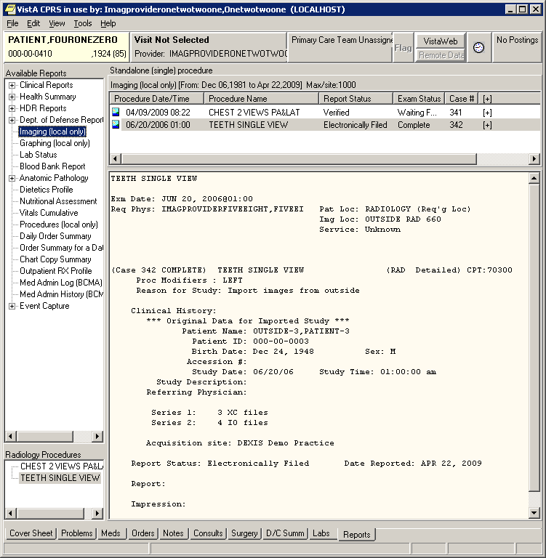
Figure 10 – CPRS Radiology Study Details

Deleting (not Importing) Transmitted DICOM Studies
Let’s assume that a set of dummy images were acquired for a test study and were transmitted to the DICOM gateway. This test study appears on the list of importable DICOM studies and needs to be deleted.
When the user selects a transmitted study, there are four options that can be used. In addition to the three options listed in previous section 3.1.1.4, there is also an option to delete the study. (This option is not necessary for DICOM studies being imported from portable media.)
Import DoD DICOM Studies that were Transmitted to the VA
--------------------------------------------------------

# Patient ID Patient Name Birth Sex Accession Number Date
--- -------------- ------------------------------ ---------- --- ---------------- --------
1) 000-00-0016 OUTSIDE-16,PATIENT-16 03/04/1960 F 030498-12345 03/19/97

Please enter the next study to import or enter "C" to continue: 1

Patient Name: OUTSIDE-16,PATIENT-16 Patient ID: 000-00-0016 Birth Date: Mar 4, 1960 Sex: F Accession #: 030498-12345 Study Date: 03/19/97 Study Time: 11:47:19 am Referring Physician: Physician,Referring
Study Instance UID: 2.16.840.1.113662.2.1.486876813333.429.33.100100
Sent by Calling AE Title: DICOM_TEST

Is this the correct study/view images (or delete the study)? [enter Y, N, V (or DEL)] v// ?
Please enter one of the following options:
Yes -- when you are ready to assign this study to a patient
No -- if you want to skip this study and select a different one
View -- when you want to display the DICOM objects for this study
DELete -- should you want to delete this study (you must use "DEL")

Is this the correct study/view images (or delete the study)? [enter Y, N, V (or DEL)] v// del

Are you sure that you want to delete this study and not import it into VistA? n // y

Each study that is to be deleted is then identified with a lower-case green “d” on the Study Selection screen, like below:

1)d 000-00-0016 OUTSIDE-16,PATIENT-16

The final prompt indicates that DICOM objects will be deleted.
Ready to delete the DICOM objects? n // Y
Deleting #1 .

Press <Enter> to continue...
The DICOM objects are removed from the C:\DICOM\IMAGE_IN folder and from the list of importable DICOM studies.

Details of Study Checking

Flagging Non-supported DICOM Objects
Each DICOM object is checked against the list of VistA supported SOP Classes and Transfer Syntaxes (stored in SCP_LIST.DIC). If a DICOM object has a non-VistA supported SOP Class and Transfer Syntax, the user is notified that the DICOM object cannot be imported. The following message will be displayed and the study will be flagged with a question mark (“?”) on the Study Selection list.

**************************************************************
*** There are nnn objects that cannot be stored on VistA. ***
*** Each is flagged with a yellow question mark ? below. ***
**************************************************************

Identifying Studies that have Already Been Imported
Each study’s Study Instance UID is checked to determine if the DICOM study is on file on the VistA system. If it is, patient and study identification information for the matching study is retrieved from VistA. In addition, all of the DICOM objects for the study are checked to see if they exist on VistA as well. (This is done by checking if their SOP Instance UIDs are on VistA.)

The Importer application will notify the user when a Study Instance UID of a study to be imported is already on file on VistA. One of the following four situations may have occurred.

- The study was previously imported and doesn’t need to be imported again. (Perhaps the user tried to import the same DICOM objects from the CD a second time.) The study is flagged with a red lowercase “c” on the study selection list.

*******************************************************************
*** There are nnn studies that are completely stored on VistA. ***
*** Each is flagged with a red lowercase “c” below. ***
*******************************************************************

- Part of the study has already been imported, while the rest of the study remains to be imported. (Perhaps some of the DICOM objects were transmitted earlier and were imported in a previous session.) The study is flagged with a yellow lowercase “p” on the study selection list.

******************************************************************
*** There are nnn studies that are partially stored on VistA. ***
*** Each is flagged with a yellow lowercase “p” below. ***
******************************************************************

- The Study Instance UID is already on file for one or more different studies. The study is highlighted in yellow and flagged with an asterisk “*” on the study selection list.

- The Study Instance UID is in use for part of the study that has been imported and is also in use for one or more other studies. The study is highlighted in yellow and flagged with an asterisk “*” on the study selection list.

Note: Try to avoid storing DICOM objects in VistA with a duplicate Study Instance UID, if at all possible. In scenario #3, the Importer will automatically replace the original Study Instance UID with a newly created one that is unique. In scenario #4, probably the best strategy would be to continue using the original UID for the DICOM objects that need to be import. Fortunately, the incidence of duplicate Study Instance UID is low, maybe on the order of one in a few thousand.

Import Reconciliation Process

Import reconciliation is a standardized process defined by the IHE Radiology Technical Framework (Import Reconciliation Workflow) by which outside DICOM objects have their patient and study information replaced with local system information in order to enable successful importation.

The following data elements in the header of each DICOM object are modified and then the object is placed on the image input queue for processing:

- Replace the following data elements in the header of each imported DICOM object with values from VistA:

(0008,0050) Accession Number
(0010,0010) Patient Name
(0010,0020) Patient ID
(0010,0021) Issuer of Patient ID (always set to “USVHA”)
(0010,0030) Date of Birth
(0010,0040) Sex
(0010,1000) Other Patient IDs (set to the VA Integration Control Number)

- Save the original values for these data elements in the Original Attributes Sequence (0040,0555).

- Add a Contributing Equipment Sequence (0018,A001) which includes the Importer User name in the Operator’s Name (0008,1070) DICOM element.

Importer Session Log Files

The activity of every Importer Session is record in a log file which can be easily imported into Microsoft Excel for viewing. The log file is located in the directory C:\DICOM\Importer_Log. (The log files are chronologically named.)

To import this file into Microsoft Excel for viewing, use the following steps:

- Click on the log file (*.CSV)
  - MS Excel will automatically launch

- If you have MS Excel 2003
  - Select all (ctrl-A)
  - Format
    - Column
      - AutoFit Selection

- If you have MS Excel 2007
  - Select all (ctrl-A)
  - Then on the Home tab, in the Cells group, click on Format
  - Under Cells Size, click on AutoFit Column Width

The Figure 11 – Importer Session Spreadsheet illustrates an Importer log in Excel 2007.
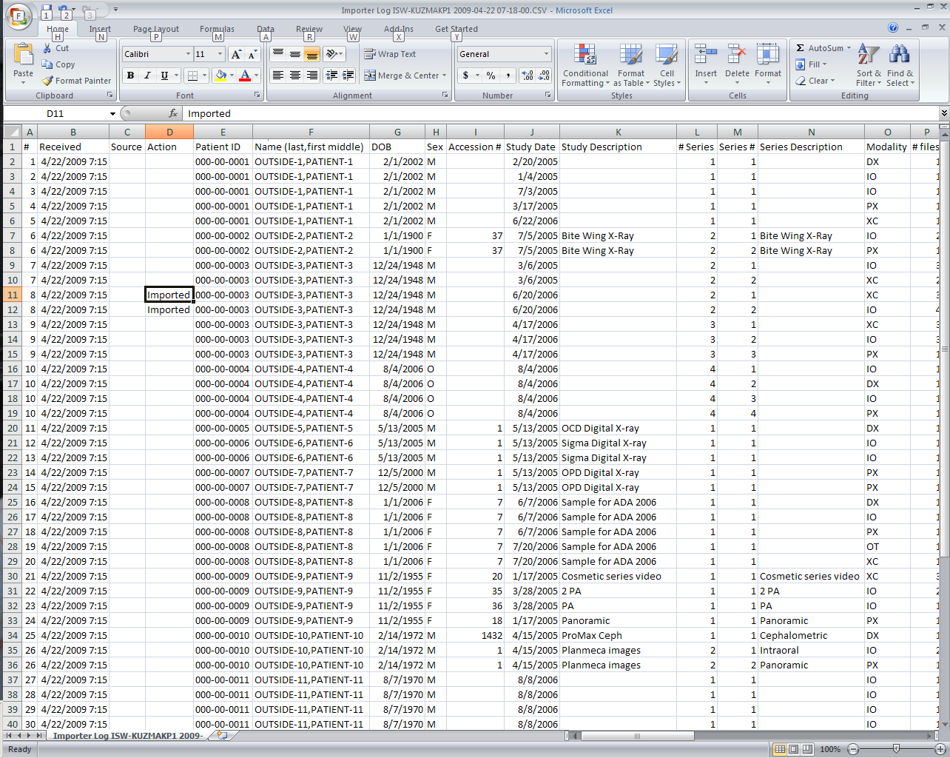
Figure 11 – Importer Session Spreadsheet

Appendix A

Setting up Outside Imaging Locations for the DICOM Importer
When an unordered prior outside radiology study is imported into VistA, an order is automatically placed for it. The VistA order created for the outside radiology study should not accrue workload statistics for VA technical or professional components because the exam was neither performed in the VA nor interpreted by the VA. For this reason, the order created on VistA should use a Radiology imaging location (entry in file #79.1) with a CREDIT METHOD = No Credit.
The VistA Imaging OUTSIDE IMAGING LOCATION file (#2006.5759) is used by the DICOM Importer to designate the entry in the Radiology IMAGING LOCATIONS file (#79.1) with CREDIT METHOD = No Credit that is to be used for the order created on VistA. There has to be one entry in the VistA Imaging OUTSIDE IMAGING LOCATION file for each enabled Radiology Imaging Type in each division.
The standard Radiology Package tools are used for creating the entries in the Radiology IMAGING LOCATIONS file. These include Parameter Set-up [RA SYSLOC] and Division Parameter Set-up [RA SYSDIV] options of the System Definition Menu [RA SYSDEF] . VistA Imaging provides the IMPORTER menu for constructing the OUTSIDE IMAGING LOCATION file.
A Radiology/Nuclear Medicine ADPAC should perform the modifications to Radiology Division and Imaging Locations files, as only they have the necessary radiology supervision menu privileges.

Note: If a site already has a No Credit outside location established for a Radiology Imaging Type for a division, it may be used instead of creating a new one.

Step 1 – Identify Imaging Types and Divisions that need “No Credit” Imaging Locations
This step is performed by VistA Imaging site personnel.
Log into VistA and select the IMPORTER menu and the Check Outside Imaging Location file option. In this example there are two enabled Image Types (General Radiology and Nuclear Medicine ) for the Salt Lake City Division.
DVA>D ^XUP

Setting up programmer environment
This is a TEST account.

Terminal Type set to: C-VT100

Select OPTION NAME: IMPORTER MENU MAG IMPORTER MENU Importer Menu
Build Outside Imaging Location file
Check Outside Imaging Location file
Display Studies to be Imported

Select Importer Menu Option: Check Outside Imaging Location file

Checking the Radiology files...
Division: SALT LAKE CITY
GENERAL RADIOLOGY - Define "No Credit" Imaging Location!
NUCLEAR MEDICINE - Define "No Credit" Imaging Location!

Please define missing "No Credit" imaging locations for the aforementioned
divisions and imaging types (using the Location Parameter Set-up [RA SYSLOC]
and Division Parameter Set-up [RA SYSDIV] options of the System Definition
Menu ... [RA SYSDEF] options) and then run this option again.

Note that the SALT LAKE CITY Division has two Imaging Types (GENERAL RADIOLOGY and NUCLEAR MEDICINE) that need to have a “NO CREDIT” Imaging Location defined for them. The Radiology ADPAC will do this in Step 2 – Step 4.

If the site already has a No Credit imaging location already defined for the imaging type, the ADPAC does not have to create a new No Credit imaging location. The ADPAC should create the “OUTSIDE STUDY” Camera/Equip/Rm, however, and assign it to the No Credit imaging location.

Step 2 – Create the OUTSIDE STUDY entry in the CAMERA/EQUIP/RM file
This step is performed by a Radiology ADPAC.

Select the RA SYSDEF menu. Edit the Camera/Equip/Rm parameters. Create a new OUTSIDE STUDY and enter the description “Study performed outside of this facility”.

DVA>D ^XUP

Setting up programmer environment
This is a TEST account.

Terminal Type set to: C-VT100
← RA SYSDEF
Select OPTION NAME: RA SYSDEF System Definition Menu

Camera/Equip/Rm Entry/Edit
Division Parameter Set-up
List of Cameras/Equip/Rms
Location Parameter List
Location Parameter Set-up
Print Division Parameter List
← CAMERA option
Select System Definition Menu Option: Camera/Equip/Rm Entry/Edit
Select Camera/Equip/Room: ?
Answer with CAMERA/EQUIP/RM, or DESCRIPTION
Choose from:
PORTABLE MOBILE PICTURES
TD RAD-EXAM1 This is the primary x-ray room.
TD RAD-EXAM2 Sonograms are done in this room.
TD RAD-EXAM3 Endoscopies are done in this room.

You may enter a new CAMERA/EQUIP/RM, if you wish
Enter a name for this camera/equip/rm, between 1 and 30 characters in
length.

Select Camera/Equip/Room: OUTSIDE STUDY
Are you adding 'OUTSIDE STUDY' as a new CAMERA/EQUIP/RM (the 5TH)? No// Y
(Yes)
CAMERA/EQUIP/RM DESCRIPTION: Study performed outside of this facility
CAMERA/EQUIP/RM: OUTSIDE STUDY//
DESCRIPTION: Study performed outside of this facility
Replace

Select Camera/Equip/Room: ?
Answer with CAMERA/EQUIP/RM, or DESCRIPTION
Choose from:
OUTSIDE STUDY Study performed outside of this facility
PORTABLE MOBILE PICTURES
TD RAD-EXAM1 This is the primary x-ray room.
TD RAD-EXAM2 Sonograms are done in this room.
TD RAD-EXAM3 Endoscopies are done in this room.

You may enter a new CAMERA/EQUIP/RM, if you wish
Enter a name for this camera/equip/rm, between 1 and 30 characters in
length.

Select Camera/Equip/Room:

Camera/Equip/Rm Entry/Edit
Division Parameter Set-up
List of Cameras/Equip/Rms
Location Parameter List
Location Parameter Set-up
Print Division Parameter List

Select System Definition Menu Option:

Do you really want to halt? YES//

Step 3 – Add new Outside Imaging Locations for each Imaging Type to Divisions
This step is performed by a Radiology ADPAC.

For each division, enter the name of each outside imaging location, one for each enable Imaging Type for the Division. The suggested naming convention is “OUTSIDE <Division Mnemonic> <Imaging Type Abbreviation>”.

Naming Convention Example

In this fictitious example, let us say that the facility has the following Imaging Types enabled:

Imaging Type (from IMAGING TYPE file #79.2) | Abbreviation
GENERAL RADIOLOGY | RAD
NUCLEAR MEDICINE | NUC MED
ULTRASOUND | US
MAGNETIC RESONANCE IMAGING | MRI
CT SCAN | CT
ANGIO/NEURO/INTERVENTIONAL | ANGIO
CARDIOLOGY STUDIES (NUC MED) | CARD
VASCULAR LAB | VAS
MAMMOGRAPHY | MAM

Let us also say that the facility has two divisions “SALT LAKE CITY VAMC” and “CLEAR WATER LAKE VAMC”. We chose “SLC” as the division mnemonic for the first, and “CWL” for the mnemonic for the second.

Here is the list of Outside Imaging Locations that we need to add to the system:

OUTSIDE SLC RAD | OUTSIDE CWL RAD
OUTSIDE SLC NUC MED | OUTSIDE CWL NUC MED
OUTSIDE SLC US | OUTSIDE CWL US
OUTSIDE SLC MRI | OUTSIDE CWL MRI
OUTSIDE SLC CT | OUTSIDE CWL CT
OUTSIDE SLC ANGIO | OUTSIDE CWL ANGIO
OUTSIDE SLC CARD | OUTSIDE CWL CARD
OUTSIDE SLC VAS | OUTSIDE CWL VAS
OUTSIDE SLC MAM | OUTSIDE CWL MAM

End of Naming Convention Example.

In the rest of the examples, for sake of simplicity, there will only be the SALT LAKE CITY Division and two IMAGE TYPES: GENERAL RADIOLOGY and NUCLEAR MEDICINE.
Select the RA SYSDEF menu. Select a Division. Take the defaults until you get to the “Imaging Locations Associated with this Division:” section. Enter the name of each outside imaging location, one for each enable Imaging Type for the Division.

In this example we are creating the Imaging Locations “OUTSIDE SLC RAD” and “OUTSIDE SLC NUC MED” (the others are created the same way). For each location, select HOSPITAL LOCATION TYPE: CLINIC, HOSPITAL LOCATION TYPE EXTENSION: CLINIC//, and the appropriate Imaging Type.

DVA>D ^XUP

Setting up programmer environment
This is a TEST account.

Terminal Type set to: C-VT100
← RA SYSDEF
Select OPTION NAME: RA SYSDEF System Definition Menu

Camera/Equip/Rm Entry/Edit
Division Parameter Set-up
List of Cameras/Equip/Rms
Location Parameter List
Location Parameter Set-up
Print Division Parameter List

Select System Definition Menu Option: DIVision Parameter Set-up
← DIVISION option

Select Division: 660 SALT LAKE CITY UT 660
← Station Number

...OK? Yes// (Yes)

Division-wide Order Entry Parameters:
------------------------------------
ASK 'IMAGING LOCATION': NO//
TRACK REQUEST STATUS CHANGES: NO//
CLINICAL HISTORY MESSAGE:

Exam Entry/Edit Parameters:
---------------------------
DETAILED PROCEDURE REQUIRED: no//
ASK 'CAMERA/EQUIP/RM': no//
AUTO USER CODE FILING: yes//
TRACK EXAM STATUS CHANGES: no//
TIME LIMIT FOR FUTURE EXAMS:

Films Reporting Parameters:
---------------------------
ALLOW STANDARD REPORTS: yes//
ALLOW BATCHING OF REPORTS: yes//
ALLOW COPYING OF REPORTS: yes//
IMPRESSION REQUIRED ON REPORTS: yes//
ALLOW VERIFYING BY RESIDENTS: yes//
ALLOW RPTS ON CANCELLED CASES?: no//
WARNING ON RPTS NOT YET VERIF?: yes//
AUTO E-MAIL TO REQ. PHYS?:
ALLOW E-SIG ON COTS HL7 RPTS: no//
INTERPRETING STAFF REQ'D?: YES//

Miscellaneous Division Parameters:
----------------------------------
PRINT FLASH CARD FOR EACH EXAM: no//
PRINT JACKET LBLS W/EACH VISIT: no//
CONTRAST REACTION MESSAGE:
RPHARM DOSE WARNING MESSAGE:
No existing text
Edit? NO//

HL7 Applications Associated with this Division:
-----------------------------------------------
Select HL7 RECEIVING APPLICATION:

Imaging Locations Associated with this Division:
------------------------------------------------
Select IMAGING LOCATION: TD-MAINRAD// OUTSIDE SLC RAD
← 1st New Outside Location
Are you adding 'OUTSIDE SLC RAD' as
a new HOSPITAL LOCATION? No// Y (Yes)
HOSPITAL LOCATION TYPE: ?
Choose from:
C CLINIC
M MODULE
W WARD
Z OTHER LOCATION
N NON-CLINIC STOP
F FILE AREA
I IMAGING
OR OPERATING ROOM
← Hospital Location Type and Extension
HOSPITAL LOCATION TYPE: C CLINIC
HOSPITAL LOCATION TYPE EXTENSION: CLINIC//
Are you adding 'OUTSIDE SLC RAD' as
← New IMAGING LOCATIONS file
a new IMAGING LOCATIONS (the 3RD)? No// Y (Yes)
IMAGING LOCATIONS TYPE OF IMAGING: ?
Enter an imaging type for this location.
Answer with IMAGING TYPE TYPE OF IMAGING, or ABBREVIATION
Choose from:
ANGIO/NEURO/INTERVENTIONAL
CARDIOLOGY STUDIES (NUC MED)
CT SCAN
GENERAL RADIOLOGY
MAGNETIC RESONANCE IMAGING
MAMMOGRAPHY
NUCLEAR MEDICINE
ULTRASOUND
VASCULAR LAB
← Imaging Type
IMAGING LOCATIONS TYPE OF IMAGING: GENERAL RADIOLOGY
Are you adding 'OUTSIDE SLC RAD' as
a new IMAGING LOCATIONS (the 3RD for this RAD/NUC MED DIVISION)? No// Y
(Yes)
← 2ND New
Outside Location
Select IMAGING LOCATION: OUTSIDE SLC RAD// OUTSIDE SLC NUC MED
Are you adding 'OUTSIDE SLC NUC MED' as
a new HOSPITAL LOCATION? No// Y (Yes)
HOSPITAL LOCATION TYPE: C CLINIC
HOSPITAL LOCATION TYPE EXTENSION: CLINIC//
Are you adding 'OUTSIDE SLC NUC MED' as
a new IMAGING LOCATIONS (the 4TH)? No// Y (Yes)
IMAGING LOCATIONS TYPE OF IMAGING: NUCLEAR MEDICINE

** Caution: You are activating a new Imaging Type. **
This means you will have to assign procedures to
this imaging type. Workload reports will be printed
separately for this Imaging Type.

Are you sure? YES

Are you adding 'OUTSIDE SLC NUC MED' as
a new IMAGING LOCATIONS (the 4TH for this RAD/NUC MED DIVISION)? No// Y
(Yes)
Select IMAGING LOCATION:
Division Parameters have been set!

Imaging Location TD-RAD is OK.

Imaging Location TD-MAINRAD is OK.

Imaging Location file #79.1 entry OUTSIDE SLC RAD has a missing
or invalid DSS ID. The Radiology/Nuclear Medicine ADPAC should
use the Location Parameter Set-up [RA SYSLOC] option to enter
a valid imaging DSS Code for this imaging location.

Imaging Location file #79.1 entry OUTSIDE SLC NUC MED has a missing
or invalid DSS ID. The Radiology/Nuclear Medicine ADPAC should
use the Location Parameter Set-up [RA SYSLOC] option to enter
a valid imaging DSS Code for this imaging location.

Select Division:

Step 4 – Define Outside Imaging Locations Parameters
This step is performed by a Radiology ADPAC.

Use the Location Parameter Set-up menu option to specify the CAMERA/EQUIP/RM, and set the CREDIT METHOD to “No Credit” and the DSS ID to “X-RAY”.

DVA>D ^XUP

Setting up programmer environment
This is a TEST account.

Terminal Type set to: C-VT100
← RA SYSDEF
Select OPTION NAME: RA SYSDEF System Definition Menu

Camera/Equip/Rm Entry/Edit
Division Parameter Set-up
List of Cameras/Equip/Rms
Location Parameter List
Location Parameter Set-up
Print Division Parameter List

Select System Definition Menu Option: LOC
1 Location Parameter List
← Select Location Set-up option
2 Location Parameter Set-up
CHOOSE 1-2: 2 Location Parameter Set-up

Select Location: OUTSIDE SLC RAD
← Select 1st location to update
...OK? Yes// Y (Yes)
(GENERAL RADIOLOGY-660)

Imaging Location: OUTSIDE SLC RAD

Flash Card Parameters:
----------------------
HOW MANY FLASH CARDS PER VISIT:
DEFAULT FLASH CARD FORMAT:

No default flash card printer has been assigned. Contact IRM.

Jacket Label Parameters:
------------------------
As specified in the division parameters, no jacket labels will
be printed automatically upon a patient visit.

DEFAULT JACKET LABEL FORMAT:

No default jacket label printer has been assigned. Contact IRM.

Exam Label Parameters:
----------------------
HOW MANY EXAM LABELS PER EXAM: 1//
DEFAULT EXAM LABEL FORMAT:

Exam label printer is always the same as the flash card printer.

Order Entry Parameters:
----------------------

No default request printer has been assigned. Contact IRM.

Report Parameters:
------------------
DEFAULT REPORT HEADER FORMAT:
DEFAULT REPORT FOOTER FORMAT:
REPORT LEFT MARGIN: 10//
REPORT RIGHT MARGIN: 70//
PRINT DX CODES IN REPORT?:
VOICE DICTATION AUTO-PRINT:

No default report printer has been assigned. Contact IRM.

Cameras/Equip/Rooms Used by this Location:
------------------------------------------
Select CAMERA/EQUIP/RM: ?
'^' TO STOP:

You may enter a new CAMERAS/EQUIP/RMS, if you wish
Enter all the cameras/equip/rms for this location.

Answer with CAMERA/EQUIP/RM, or DESCRIPTION
Choose from:
OR1 OR RM 1
OR2 OR RM 2
PORTABLE MOBILE PICTURES
RM0 2150
RM2 RM 2151
RM3 CHEST UNIT
OUTSIDE STUDY Study performed outside of this facility
TD RAD-EXAM1 This is the primary x-ray room.
TD RAD-EXAM2 Sonograms are done in this room.
TD RAD-EXAM3 Endoscopies are done in this room.

You may enter a new CAMERA/EQUIP/RM, if you wish
Enter a name for this camera/equip/rm, between 1 and 30 characters in
length.

Select CAMERA/EQUIP/RM: OUTSIDE STUDY Study performed outside of this facility
Are you adding 'OUTSIDE STUDY' as a new CAMERAS/EQUIP/RMS (the 1ST for this IMAGING LOCATIONS)? No// Y (Yes)
Select CAMERA/EQUIP/RM:

Default CPT Modifiers used by this Location:
--------------------------------------------
+----------------------------------------------------------------+
| Your entry cannot be compared with a CPT CODE, so be very sure |
| that this is the Default CPT Modifier that you want to stuff |
| into every registered exam from this imaging location. |
+----------------------------------------------------------------+
Select DEFAULT CPT MODIFIERS(LOC): ?

You may enter a new DEFAULT CPT MODIFIERS(LOC), if you wish

VA local modifiers are automatically screened out (rejected.)

+----------------------------------------------------------------+
| Your entry cannot be compared with a CPT CODE, so be very sure |
| that this is the Default CPT Modifier that you want to stuff |
| into every registered exam from this imaging location. |
+----------------------------------------------------------------+
Choose a CPT Modifier that should be automatically stuffed
into the exam record, when the following 2 conditions
are both met :
1-There is no default CPT Modifier for this exam's procedure.
2-This location is the current sign-on (or switched-to) location
at the time of registration.
If your entry is invalid, then during exam registration, this
Default CPT Modifier will NOT be stuffed, instead, an error message
with the name of the rejected CPT Modifier would be displayed.

Answer with CPT MODIFIER, or NAME, or CODE, or BEGIN CPT RANGE, or
END CPT RANGE
Do you want the entire CPT MODIFIER List? N

Select DEFAULT CPT MODIFIERS(LOC):

Recipients of the 'Stat' Alert for this Location:
-------------------------------------------------
Select STAT REQUEST ALERT RECIPIENTS:

ALLOW 'RELEASED/NOT VERIFIED': no// no
INACTIVE:
TYPE OF IMAGING: GENERAL RADIOLOGY//
CREDIT METHOD: 0// ?
Enter the type of credit this location will receive for this examination.
Choose from:
← CREDIT METHOD =
2 “No Credit”
0 Regular Credit
1 Interpretation Only
2 No Credit
3 Technical Component Only
CREDIT METHOD: 0// 2 No Credit
DSS ID: ?
Enter a valid stop code for this imaging location.
Only Stop Codes entered in the Imaging Stop Codes file may be selected.
Answer with CLINIC STOP NAME, or AMIS REPORTING STOP CODE
Do you want the entire CLINIC STOP List?
DSS ID: X-RAY 105
← DSS ID = “X-RAY”
Imaging Location OUTSIDE SLC RAD is OK.

Update the other locations in exactly the same fashion.

Select Location:

Camera/Equip/Rm Entry/Edit
Division Parameter Set-up
List of Cameras/Equip/Rms
Location Parameter List
Location Parameter Set-up
Print Division Parameter List

Select System Definition Menu Option:

Do you really want to halt? YES//

Step 5 – “OUTSIDE STUDY” Camera/Equip/Room for all Radiology Imaging Location
This step is performed by a Radiology ADPAC.

Every Radiology Imaging Location that is used for a contract outside imaging facility needs to have “OUTSIDE STUDY” camera/equipment/room assigned to it. When the study is imported, the examination/report status of the case is advanced to either “Examined/No Report” if it is to be read locally or “Complete/Electronically Filed” if it is finished.

If DICOM objects are imported for a study with a Radiology Imaging Location that does not have the “OUTSIDE STUDY” camera/equipment/room assigned to it, a message like the one below will be displayed in the Importer session. The examination/report status will then need to be manually advanced.

************************************************************************************
*** WARNING: Exam/Report status not advanced to COMPLETE/ELECTRONICALLY FILED ***
*** ***
*** The Camera/Equipment/Room "OUTSIDE STUDY" is not defined for the Radiology ***
*** Imaging Location "XXXXXXXXXX" that is used for this study. ***
*** ***
*** The data required to advance the status of this case performed at an outside ***
*** location has not been entered. ***
*** ***
*** Due to this condition, the status of the study had not been automatically ***
*** advanced. Please manually advance its status by entering the necessary data ***
*** using the Radiology package status tracking option. ***
*** ***
*** Message generated at MUMPS line tag ERR1102+13^MAGDAIRC ***
************************************************************************************
Step 6 – Populate VistA Imaging Outside Imaging Location file
This step is performed by VistA Imaging site personnel.
Log into VistA and select the IMPORTER menu and the Build Outside Imaging Location file option. In this example there are two enabled Image Types (General Radiology and Nuclear Medicine ) for the Salt Lake City Division. Both of these now have CREDIT METHOD = “No Credit” entries in the Radiology DIVISION and IMAGING LOCATIONS file. The Build Outside Imaging Location file option will interactively help you add/change entries in the file.
When you have finished, run the Build Outside Imaging Location file option to verify that everything is setup correctly.

DVA>D ^XUP

Setting up programmer environment
This is a TEST account.

Terminal Type set to: C-VT100

Select OPTION NAME: IMPORTER MENU MAG IMPORTER MENU Importer Menu

Build Outside Imaging Location file
Check Outside Imaging Location file
Display Studies to be Imported

Select Importer Menu Option: Build Outside Imaging Location file

Checking the Radiology files...
Division: SALT LAKE CITY

Checking the OUTSIDE IMAGING LOCATION file (#2006.5759)...

Division: SALT LAKE CITY
GENERAL RADIOLOGY - Create record in file #2006.5759!
NUCLEAR MEDICINE - Create record in file #2006.5759!
Please fix the aforementioned problems in the OUTSIDE IMAGING LOCATION file
(#2006.5759) and then run this option again.

OUTSIDE IMAGING LOCATIONS for SALT LAKE CITY (660)
--------------------------------------------------
GENERAL RADIOLOGY -- (not defined yet)
← OUTSIDE SLC RAD
OUTSIDE SLC RAD
Use this value?? n// YES

NUCLEAR MEDICINE -- (not defined yet)
← OUTSIDE SLC NUC MED
OUTSIDE SLC NUC MED
Use this value?? n// YES

Build Outside Imaging Location file
Check Outside Imaging Location file
Display Studies to be Imported

Select Importer Menu Option: Check Outside Imaging Location file

Checking the Radiology files...
Division: SALT LAKE CITY

Checking the OUTSIDE IMAGING LOCATION file (#2006.5759)...

Division: SALT LAKE CITY
GENERAL RADIOLOGY - OUTSIDE SLC RAD
NUCLEAR MEDICINE - OUTSIDE SLC NUC MED

Build Outside Imaging Location file
Check Outside Imaging Location file
Display Studies to be Imported

Select Importer Menu Option:

Do you really want to halt? YES//

Appendix B

Running the Importer from a Remote Desktop
This Appendix describes the initiation and configuration of Terminal Services on a DICOM Gateway running Microsoft Windows Server 2003 and Microsoft Remote Desktop (RDP) client on Microsoft Windows XP.
The Importer application was written to run on a DICOM Image Gateway. The Microsoft Remote Desktop (RDP) Terminal Service client was used during internal testing for the sake of convenience so that the tester could exercise the Importer from his office when it was running on a Gateway located in the computer room. The operation of the Importer application is the same whether it runs locally or remotely. The only difference is that the DICOM Gateway needs to map the CD/DVD drive on the remote system and that the Importer User must run the Remote Desktop application supplied with the operating system.
Note: Imaging support personnel at several sites have found it easier to install a dedicated DICOM Gateway in Radiology for the purpose of running the Importer application.

Microsoft Terminal Server Installation

Licensing the Terminal Server on Windows Server 2003
Administrator Remote Desktop permits members of the administrator group to remotely access a Windows Server 2003. Each Windows Server 2003 has a license for one administrator RDP connection. This is the license that is typically used for running the Importer Application from a remote workstation.
Terminal Server is the same product with a multi-user license that allows simultaneous access by multiple remote clients to Windows-based programs that run on the server. When you use Terminal Server, the server accepts more than two simultaneous connections by non-administrators. When you use Terminal Server, you can install the Terminal Services Licensing service on any member server. However, you must configure a preferred license server on all terminal servers that have to communicate with non-domain controller license servers that are configured as domain license servers. Enterprise domain license servers that are deployed on non-domain controllers are automatically discovered.

Installing Terminal Server
- Install Terminal Server on an Importer DICOM Gateway running Windows Server 2003.
  - Click Start, click Control Panel, and then double-click Add or Remove Programs.
  - Click Add/Remove Windows Components.
  - In the dialog box, select Terminal Server.
  - Click Next. Terminal Server will install
  - Follow the instructions in the Windows Components Wizard.
Three questions will be asked about: “Full Security or Relaxed Security”, “Location of License Server”, and “Client Access License”. Use the configuration options that are standard for your site.
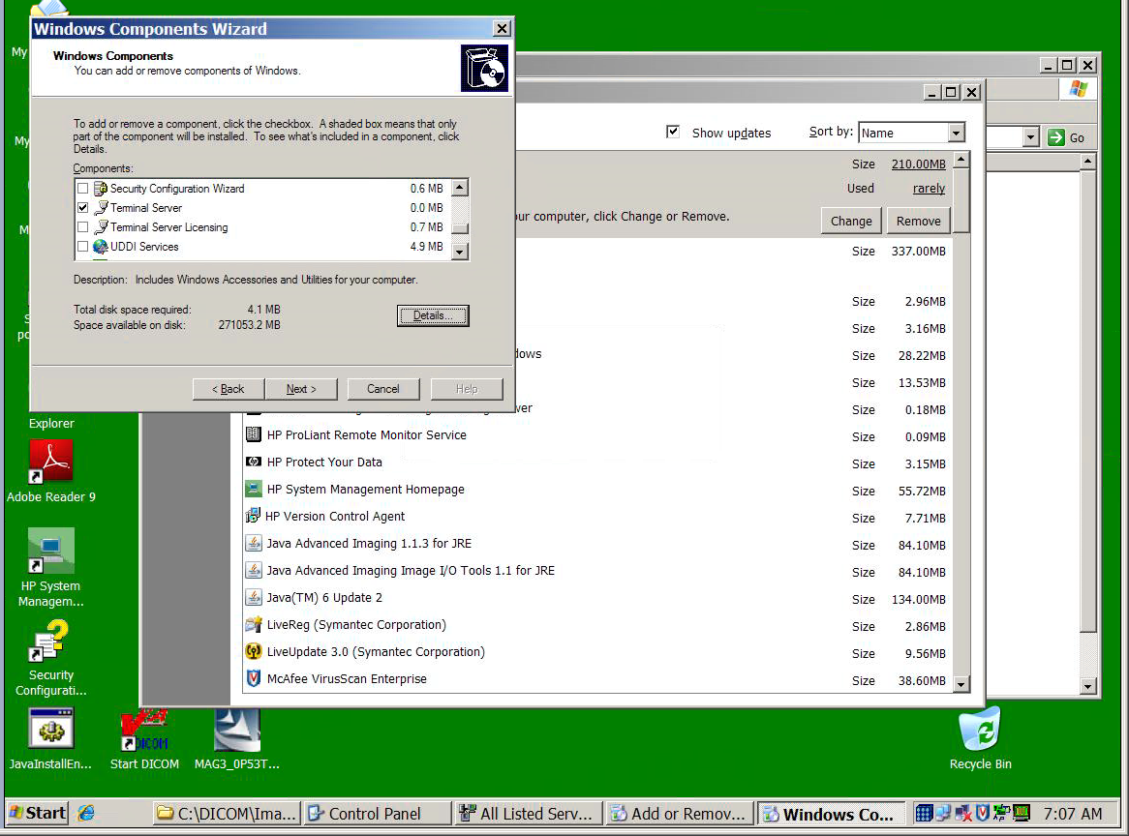
Figure 12 – Enabling Terminal Server on Add/Remove Windows Components
- Add the Importer Users to the administrator group on the Importer DICOM Gateway.
  - Click Start, click Control Panel, click Administrative Tools, and click Computer Management.
  - Add the account of each Importer User to the administrator group.
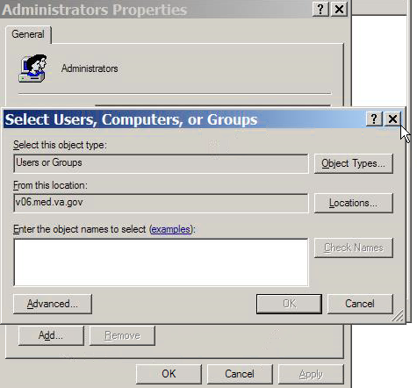
Figure 13 – Adding Import Users to the Administrator Group

Setup the Remote Desktop Client on a Windows XP Workstation
Perform the following procedure on each client workstation that will be used to remotely run the Importer application.
- Open the Remote Desktop Connection properties window.
  - Click Start, click All Programs, click Accessories, and click Remote Desktop Connection. (You may have to install this on the system(s) by local OI&T rules.)

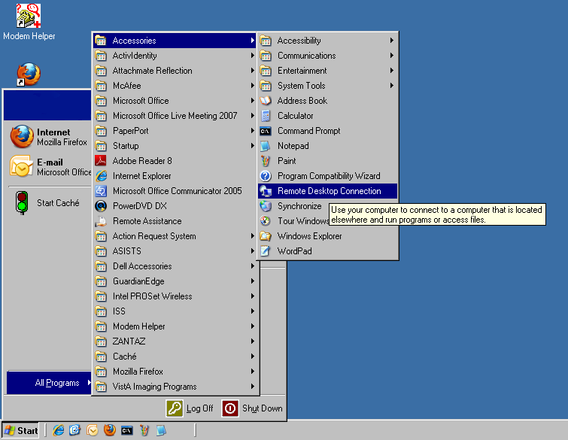
Figure 14 – Starting Remote Desktop Connection

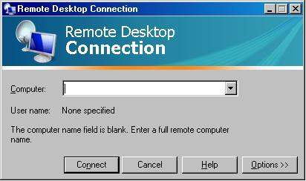
Figure 15 – Specifying the Importer DICOM Gateway Terminal Server
- Click on Options >> and the General tab. Enter the IP address of an Importer DICOM Gateway computer, enter the User name and click on Save.
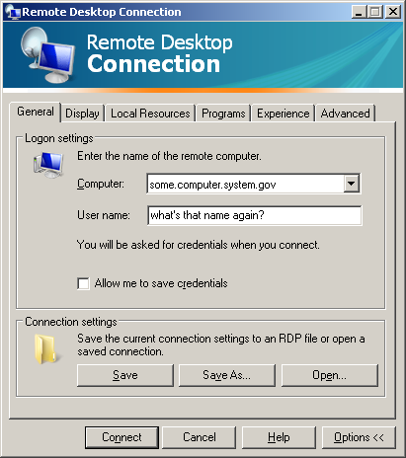
Figure 16 – Entering User name for Remote Desktop Connection

- Click on the Display tab. Set the Remote desktop size to 1280 by 1024 pixels and Colors to Highest Quality (32 bit). Check the box for “Display the connection bar when in full screen mode”. Note: The Windows XP workstation MUST be able to support 1280 by 1024 pixels and 32 bit color.
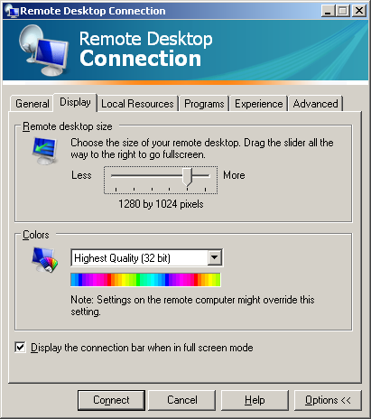
Figure 17 – Setting the Screen Resolution and Color Quality
- (Skip Local Resources and Programs.) Click on the Experience tab. Check all the boxes. (Skip Advanced.)
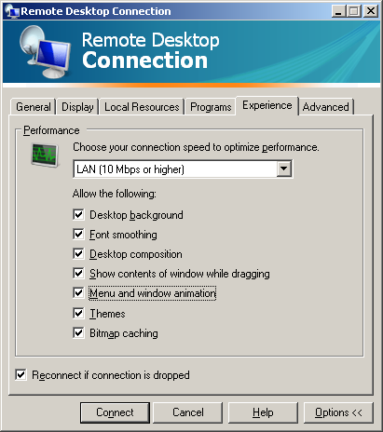
Figure 18 – Setting Network Performance Parameters
- Close the Remote Desktop Connection window by clicking on in the upper-right corner of the window.

Division of Labor between local Gateway User and Remote User
The local Gateway User has the “FULL” (MAG DICOM GATEWAY FULL) key while the Remote User (Importer User) has the “VIEW” (MAG DICOM GATEWAY VIEW) key. It is the responsibility of the local Gateway User to start the normal continuously running processing jobs on the gateway, like the MAG_CSTORE.EXE Storage SCP listeners and the menu option 2-3 Image Processing. The Remote User does not see these processes and with the “VIEW” key, does not have the menu options that are used to control them. S/he only sees the ones that s/he has initiated, in particular the Caché Terminal Importer Session, the DICOM Viewer, and the Laurel Bridge DCF executables.

Using the Remote Desktop Connection for the Importer
- Click Start, click All Programs, click Accessories, and click Remote Desktop Connection.
Figure 19 – Starting Remote Desktop Connection
- Enter the name of the Importer DICOM Gateway and click on Connect.
Figure 20 – Specifying the Importer DICOM Gateway Terminal Server
- The Importer User remote logons to the Importer DICOM Gateway using his/her normal credentials.
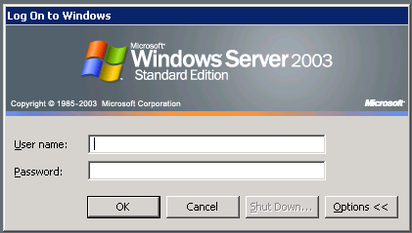
Figure 21 – Logging into Terminal Server on Importer DICOM Gateway
- The Importer User needs to map a network drive from the Importer DICOM Gateway to his/her workstation’s CD/DVD drive. If multiple people are Importer Users, each should map his/her workstation’s CD/DVD drive using a unique drive letter. Enter this drive letter at the CD/DVD Import Drive: prompt.

- Follow the Importer instructions in the body of this document.
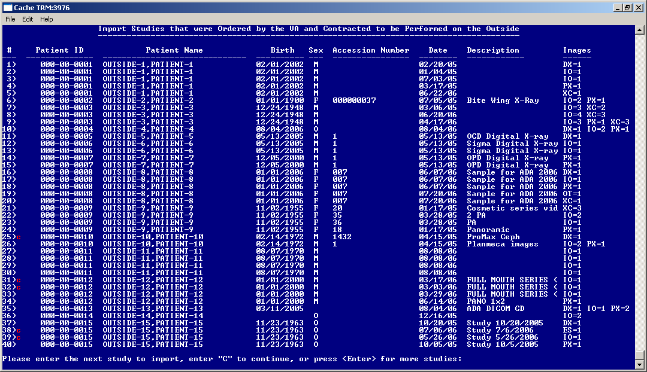
Figure 22 – Running the Importer Remotely
- When the Importer User finishes the Importer Session s/he should “Log Off” the Remote Desktop Connection. This will discontinue all the processes. Otherwise the processes will remain active.

Appendix C

Handing Parent-Descendent Procedure Orders with the Importer
VistA Radiology supports the ability to order parent procedures. Parent procedures are associated with two or more descendent procedures. When the patient is registered for the parent procedure, a separate distinct radiology study with its own unique accession number is created for each descendent procedure.
An example of a parent procedure may be “ANKLES, BILATERAL, 2 VIEWS”, which is associated with two descendant procedures: “LEFT ANKLE 2 VIEWS” and “RIGHT ANKLE 2 VIEWS”. When the patient is registered for ANKLES, BILATERAL, 2 VIEWS, two studies are created, one for LEFT ANKLE 2 VIEWS and one for RIGHT ANKLE 2 VIEWS.

How it Works
The provider orders the parent procedure through CPRS. This goes into the ORDER file (#100) and when signed the same order is filed in the RAD/NUC MED ORDERS file (#75.1). When this order is registered (for example, by the Importer or the “REG EDIT” menu option) individual studies are created for each descendent procedure and are filed into the EXAMINATIONS (#70.03) multiple which is a sub-file of the RAD/NUC MED PATIENT file (#70). Unique accession numbers are created for the study for each procedure. The study for each procedure is then treated as a separate entity for examination purposes.
Each study for each procedure may have its own unique diagnostic report (that is, be defined an Exam Set – the default) or there may be a single diagnostic report referenced by the descendant procedures (that is, be defined a Print Set). A parent procedure can be designated as a print set by exercising the Procedure Enter/Edit option and setting the SINGLE REPORT field (#18) of the parent procedure in the RAD/NUC MED PROCEDURES file (#71) to ‘Yes’.

Questions
If the VA orders a parent procedure as a fee-basis contracted examination, how does the contractor perform the procedure, how are the resultant DICOM objects created, and how should those DICOM object be imported into VistA?

How Outside Fee-basis Imaging Contractors Work
The outside imaging contractor can execute an order of “ANKLES, BILATERAL, 2 VIEWS” two different ways:
- The contractor can perform two separate studies, one for the left ankle and one for the right ankle.
- The contractor can also perform a single study which includes both ankles.
Depending upon how the contractor executes the order, there are three different ways to represent the DICOM images for the examination(s).
- If the contractor performs the bilateral ankle order as two separate studies, one for the left ankle and the other for the right ankle, then there will be two different contractor assigned accession numbers, Study Instance UIDs, procedure names, etc. for each study. Each DICOM image must have either the series Laterality (0020,0060) or the Image Laterality (0020,0062) attribute.

- If the contractor performs the bilateral ankle order as one study, there will be one contractor assigned accession number, Study Instance UID, procedure name, etc. for all the DICOM images.

  - The contractor may choose to use two separate series, one for the left ankle and the other for the right ankle, and specify the series Laterality (0020,0060) for all of the DICOM images in at series. In this case, each series will have a unique Series Instance UID.

  - The contractor may also chose to use one series for all of the ankle images, and specify the Image Laterality (0020,0062) for each DICOM image in the series. In this case, there will be only one Series Instance UID for the entire study.

How to use the Importer for DICOM Images for Parent/Descendent Procedures
The choice of the method used by the contractor to perform the examination(s) and how the resultant images are represented in DICOM have a great bearing on how the images should be imported into another system.
The Importer does not handle parent/descendent procedures automatically. Some manual effort is required to do this properly. The level of effort depends on how the study was performed and how the DICOM images were created. The following steps may be used as a guideline:
- Use Importer menu option 2 – Import Outside Contracted studies.

- Using the Importer, determine whether contractor chose to perform the bilateral ankle as one study or as two separate studies.

- If the contractor chose to perform the bilateral ankle as two separate studies, then the images from the left outside study will be imported to the left VistA study and the images from the right side outside study will be imported to the right side VistA study. Follow these steps:

  - Select only the LEFT study in the Importer.
  - Use the “lookup in Radiology Order file” option.
  - Select the patient and the order for the parent procedure.
  - Import only the LEFT study.
  - Exit the Importer application.
  - Using the VistA Rad application, the Radiology package to view by case, or CPRS Imaging (local only) Reports tab to confirm that second study for the right side study was created as a result of the bilateral study order (parent/descendant). This study will be in a “waiting for exam” status. Obtain the accession number for it.
  - Use Importer menu option 2 – Import Outside Contracted studies, and re-enter the Importer application.
  - Select the RIGHT side study in the Importer.
  - Use the “Modality Worklist” look up option.
  - Select the VistA RIGHT side procedure study for the patient by entering its accession number for the query key.
  - Import the RIGHT side study.
  - Confirm that the RIGHT side outside study’s images are attached to the VistA RIGHT side study and that the study has been completed (Exam Status = “Exam Complete” and Report Status = “Electronically Filed”).

- If the contractor performed the bilateral ankle order as one study, there will be only one accession number, Study Instance UID, procedure name, etc. for all the DICOM images. All of the outside images will be imported to the LEFT VistA study. Follow these steps:

  - Select the study in the Importer.
  - Use the “lookup in Radiology Order file” option.
  - Select the patient and the order for the parent procedure.
  - Import the study.
    - The Importer will register the parent procedure and automatically create a study for the LEFT ANKLE 2 VIEWS procedure and a study for the RIGHT ANKLE 2 VIEWS procedure.
    - The accession number for the study for the LEFT ANKLE 2 VIEWS procedure will be returned and all the images will be imported to it.
  - In the Radiology package, insert your local combined standard report stub to indicate images and report have been uploaded to the LEFT study. Then update the status manually in the Radiology package per local policy/procedures.

It is beyond the scope of the Importer to be able identify which images are for the left ankle and import them to the left procedure and identify which images are for the right ankle and import them to the right side procedure. There are two facets of this scenario that are difficult. First, the Importer works at the study level and not the series or image level. Second, DICOM images from one study cannot be filed with two different studies in VistA because this would create duplicate Study Instance UIDs and possibly duplicate Series Instance UIDs (if all the images were in the same series.) This would be a violation of the DICOM Standard and not a limitation of the Importer or VistA Imaging.

Note: It is advantageous to require that the outside contracted vendor to perform the bilateral ankle as two separate studies. Then the images can be properly associated with the corresponding two VistA studies.

Appendix D

Problems Seen in Importing of DICOM Objects from Media

Background
The DICOM Standard and the IHE Portable Data for Imaging integration profile specify the format and content of media (CDs and DVDs) that is used for interchange of DICOM objects. These specifications cover the DICOM directory file DICOMDIR, the DICOM objects, and additional material on the media (viewers, JPEG files, etc.). It is sad commentary on the state of the art, however, that some vendors still create proprietary media with proprietary viewers on board, despite the fact that these offer no advantage over standard formatted media. This is a major problem in the industry today.

The physician user community is starting to take action about the difficulty viewing and navigating through imaging examinations from some media. The following is an excerpt from a published write up by DICOM expert Dr. David Clunie:

“The American Medical Association, as a consequence of complaints initiated by the American Association of Neurological Surgeons with respect to viewing MRIs, has produced a report from their board of trustees that resulted in the passage of Resolution 539 (A-06) "Development of Standards for MRI Equipment and Interpretation to Improve Patient Safety". Note that the discontent being expressed by the AMA is not confined to neurosurgeons, but involves everyone who receives these media. Further, the emphasis is on safety, specifically, if the media is unreadable or unusable or takes too long to use, then the safety of the patient may be at risk.”

“Referring physicians made it abundantly clear that swift, dramatic and effective action by industry and by radiology facilities is expected without delay, and that delay will result in engagement of the regulators and the legislators.”

“Emphasis would be placed on establishing that the standard of care will be compliance with the IHE PDI specification, and in the absence of any explicit enforcement mechanism, promulgating this as an AMA principle may suffice. Woe betide anyone who then expects to get paid for producing non-compliant media (since payers might not pay for less than the standard of care when they become aware of the issue), or who expects to prevail in the civil courts in the event of a negligence action caused by an unfortunate outcome from inability to read the media.”

Elsewhere, Dr. Clunie vehemently singled out Philips/Stentor and Amicas as being the two major PACS vendors who still produce proprietary media with proprietary viewers.

What does this mean for the VA?

First, we ourselves should strive to provide the standard of care specified by the AMA. This is not always easy, as we are a major user of a vendor’s product (Philips/Stentor iSite) that fails to produce compliant DICOM media. We need to export our DICOM objects using commercially available IHE PDI compliant products.

Second, we need to require our fee-basis imaging contractors to provide compliant DICOM media. They need to export their DICOM objects using commercially available IHE PDI compliant products.

Third, we need to deal with problematic DICOM media that are received from other locations.

Problems
The Importer is designed to work with media that is formatted according to the DICOM Standard and the IHE Portable Data for Imaging integration profile. DICOM objects on compliant media usually are able to be imported. Those on non-compliant media may not be able to be imported.

Here is a list of some of the kinds of problems that one should expect to see.

- The media is just blank.

- The media is written improperly. Here is an example where the vendor did not enter the files into the directory correctly:

E:\>dir
Volume in drive E has no label.
Volume Serial Number is 8B34-8C3C

Directory of E:\

The parameter is incorrect. 12:00 AM 3,920 DICOMDIR
The parameter is incorrect. 12:00 AM 759 DiscView.htm
The parameter is incorrect. 12:00 AM 240 QuickViewer.txt
The parameter is incorrect. 12:00 AM 105,320 Readme1st.htm
01/15/2010 08:49 AM <DIR> Readme1st_files
The parameter is incorrect. 01/15/2010 08:49 AM 72 autorun.bat
The parameter is incorrect. 01/15/2010 08:49 AM 29 autorun.inf
01/15/2010 08:49 AM <DIR> data
6 File(s) 110,340 bytes4
2 Dir(s) 0 bytes free

E:\>

- There is no DICOMDIR on the media and the images are kept in separate sub-folders. The Importer cannot be used directly.

If there are DICOM files on the media, they might be able to be sent to a C-Store process on the Importer gateway. The BATCH_SEND_IMAGE.BAT batch file (see Appendix E) may be able to be used to extract the DICOM files from the media and send them. Otherwise, it may be necessary to use a commercial product (like Sorna) to read the media and send the DICOM files to the C-Store process.

- There are errors in DICOMDIR.

  - The file name of each DICOM object uses forward slashes, rather than back slashes, as required by the DICOM Standard.
  - The Referenced SOP Class UID (0004,1510) is wrong. (One vendor used the Media Storage Directory Storage SOP Class. Another vendor used the character string “SOP UID”. It must be the same as the SOP Class UID (0008,0016) of the DICOM object.)
  - The Referenced Transfer Syntax UID (0004,1512) is absent even though it is a Type 1 (that is, a required data element with a non-null value).
  - The Modality (0008,0060) is a DICOM Series attribute. It may not be defined in DICOMDIR for the Series directory record type even though it is a Type 1.

- DICOMDIR is fine but the DICOM objects are not able to be supported by VistA Imaging.

The subset of DICOM SOP Classes and Transfer Syntaxes that VistA Imaging supports is specified in the SCP_LIST.DIC dictionary. There are many compression transfer syntaxes that are not yet supported (these will be supported in Patch 99). Here is a sample error message:

********************************************************************************
*** ***
*** There are 871 DICOM objects that cannot be stored on VistA. ***
*** Each is flagged with a yellow question mark ? below. ***
*** ***
*** SOP Class: CT Image Storage ***
*** Transfer Syntax: JPEG Lossless, Non-Hierarchical (Process 14): Default ***
*** Lossless JPEG Compression ***
*** Problem: The Transfer Syntax is not supported -- 871 DICOM objects ***
*** ***
********************************************************************************

- Outside source places multiple patient exams on their same accession number (Skull, hand, foot all done as one exam). This is difficult to handle when this study is imported into VistA.

- The media contains only JPEG2000 images and no DICOM ones.

- One, or more, images in a study are incomplete (for example, only the top half of the chest x-ray). The image(s) fail(s) image processing.

- The exam was not done according to radiology “best practices” standard of care. For example, a fee-basis contracted order for a “knee 3 views” only has two images.

- The outside modality creates a study with a UID that is a duplicate of one which is already on VistA for another patient.

- Some of the expected DICOM header information may be incorrect or blank – for example technician name, body location, radiology location.

- The media is a copy of an earlier one. (This one is easy – the Importer automatically prevents an imported DICOM object from being imported a second time.)

Thanks to Morgan Hammac of the Fayetteville, NC VAMC for providing information about problems that were seen in the Field Test.

Appendix E

Using the BATCH_SEND_IMAGE.BAT utility script
Sometimes non-compliant portable media (like CD or DVD) contains DICOM objects but with either a malformed or an absent DICOMDIR file so that they cannot be handled directly by the Importer.
The Importer includes the BATCH_SEND_IMAGE.BAT utility script that may help in these situations.
C:\>batch_send_image
Batch DICOM File Sender

This batch file can be used to send a set of DICOM to a local C-Store process.

batch_send_image {C-Store host} {port number} {input path} [ {extension} ]

The {input path} can be either a directory on disk or one on portable media.
Only DICOM files should be in the {input path} directory tree.
This will try to send every file in the {input path} to the C-Store process.
An optional extension may be specified -- include the dot, as in ".ext".
If an extension is not specified, none will be used -- DICOM Part-10 compliant.

First Argument is the host ip address or name for the C-Store process.
Second Argument is the port number for the C-Store process.
Third Argument is the path to the folder containing the images, like "D:\DICOM".

Here is an example of its usage. The D:\DICOM folder contains 29 DICOM files. None of them have the “.DCM” extension and there is no DICOMDIR file in the root directory.
D:\DICOM>dir
Volume in drive D is 112707_0006
Volume Serial Number is DA73-57A4

Directory of D:\DICOM

11/27/2007 05:37 AM <DIR> .
11/27/2007 05:37 AM <DIR> ..
11/20/2007 12:20 PM 897,796 NAS00000
11/20/2007 12:20 PM 152,522 NAS00001
11/20/2007 12:20 PM 310,672 NAS00002
11/20/2007 12:20 PM 658,242 NAS00003
11/20/2007 12:20 PM 721,364 NAS00004
11/20/2007 12:20 PM 287,558 NAS00005
11/20/2007 12:20 PM 1,034,628 NAS00006
11/20/2007 12:20 PM 957,628 NAS00007
11/20/2007 12:20 PM 1,014,486 NAS00008
11/20/2007 12:20 PM 1,041,582 NAS00009
11/20/2007 12:20 PM 967,622 NAS00010
11/20/2007 12:20 PM 91,742 NAS00011
11/20/2007 12:20 PM 91,742 NAS00012
11/20/2007 12:20 PM 2,622,894 NAS00013
11/20/2007 12:20 PM 2,622,894 NAS00014
11/20/2007 12:20 PM 2,622,894 NAS00015
11/20/2007 12:20 PM 2,622,894 NAS00016
11/20/2007 12:20 PM 2,622,894 NAS00017
11/20/2007 12:20 PM 2,622,894 NAS00018
11/20/2007 12:20 PM 2,622,894 NAS00019
11/20/2007 12:20 PM 2,622,894 NAS00020
11/20/2007 12:20 PM 2,622,894 NAS00021
11/20/2007 12:20 PM 2,622,894 NAS00022
11/20/2007 12:20 PM 2,622,894 NAS00023
11/20/2007 12:20 PM 2,622,894 NAS00024
11/20/2007 12:20 PM 2,622,894 NAS00025
11/20/2007 12:20 PM 2,622,894 NAS00026
11/20/2007 12:20 PM 2,622,894 NAS00027
11/20/2007 12:20 PM 2,622,894 NAS00028
29 File(s) 50,193,888 bytes
2 Dir(s) 0 bytes free

First, start a MAG_CSTORE.EXE process listening on port 60100 on the system. Then use the batch script to send these DICOM objects to it.

C:\>batch_send_image localhost 60100 d:\dicom
Batch DICOM File Sender

d:\dicom\NAS00000
Store Response
Message ID Resp:1
Data Set Type: 0101
Status: 0000 Status Information:-
Successful operation
Class UID: 1.2.840.10008.5.1.4.1.1.3.1
Instance UID: 1.2.840.113680.1.103.52974.988052208.123798.1.10
.
.
.
d:\dicom\NAS00028
Store Response
Message ID Resp:1
Data Set Type: 0101
Status: 0000 Status Information:-
Successful operation
Class UID: 1.2.840.10008.5.1.4.1.1.12.1
Instance UID: 2.16.840.1.113669.632.3.111111.42020013285100.19.5.11.100800

IHE Portable Data for Imaging Integration Profile, IHE Technical Framework, vol I, Rev. 8.0, 2007-08-30.
IHE Import Reconciliation Workflow, IHE Technical Framework, vol I, Rev. 8.0, 2007-08-30.
This procedure was provided by Morgan Hammac of the Fayetteville, NC VAMC
Guidelines for Deploying Terminal Server, http://www.microsoft.com/windowsserver2003/techinfo/overview/quickstart.mspx#EPC
Greg Cebelinski of the Radiology Development Team and Jeannie Jernigan of the Fayetteville, NC VAMC contributed to this document.
PS 3.3-2009 Information Object Definitions, PS 3.10-2009 Media Storage and File Format for Media Interchange and PS 3.11-2009 Media Storage Application Profiles
Integrating the Healthcare Enterprise, IHE Radiology Technical Framework, Volume III Transactions (Continued) Revision 9.0 – Final Text, June 27, 2008, Section 4.47 Distribute Imaging Information on Media. http://www.ihe.net/Technical_Framework/upload/ihe_tf_rev9-0ft_vol3_2008-06-26.pdf
http://www.dclunie.com/blog/blog/2008/08/is-winter-of-discontent-with-cds.html
http://www.dclunie.com/blog/blog/2008/04/requirements-for-office-imaging-system.html
http://www.sorna.com/

